This END USER LICENSE AGREEMENT (“Agreement”) is a legal agreement between The Escal Institute of Advanced Technologies, Inc. /dba SANS Institute, ("SANS") and you (“End User Customer” or “Customer”). SANS and End User Customer may be referred to in this Agreement individually as a "Party" and together as the "Parties”. This Agreement also incorporates any Product Specific Terms, as defined herein, that may apply to specific Products and Services. By using the Products, the End User Customer agrees to be bound by the terms of this Agreement.

1. DEFINITIONS.

1.1. Applicable Data Protection Legislation means any data protection regulation that may apply in the context of the Agreement, including, where applicable, (i) General Data Protection Regulation - the Regulation (EU) 2016/679 on the protection of natural persons with regard to the processing of personal data and on the free movement of such data (“GDPR”) and the laws and regulations adopted to implement the GDPR and (ii) any other international, federal, state, provincial and local privacy or data protection laws, regulations, directives, and government requirements currently in effect and as they become effective relating to the Processing of Personal Data.

1.2. Confidential Information means any information that is proprietary or confidential to a Party and either marked as confidential or identified as such to the other Party, including, but not limited to, business or technical data or know-how, customer and prospective customer lists, secrets, ideas, concepts, designs, drawings, flow charts, diagrams, financials, and other intellectual property, in whatever form including, documented information, machine readable or interpreted information transmitted in any form including, in writing, orally, or visually. Any abstracts, summaries or compilations are included in this definition of Confidential Information. For avoidance of doubt, Confidential Information includes details of SANS training courses or exams, pricing, courseware, user information, and the business relationship between the Parties.

1.3. End User Customer Materials means End User Customer-sourced data or materials not provided by SANS or its suppliers, that are used in connection with Workforce Training Materials, such as End User Customer-sourced content, logos, artwork, or media.

1.4. Disclosing Party means the Party that discloses its Confidential Information to the Receiving Party under this Agreement.

1.5. Engagement Materials means SANS fact sheets, FAQs, help files, media files, newsletters, posters, and screensavers provided or made available to facilitate use of the SANS Products. Engagement Materials do not include Workforce Training Materials themselves.

1.6. License Term means the period beginning upon End User Customer’s receipt of SANS’ invoice for Product(s) and/or Service(s) under any Price Quote, statement of work, or other means.

1.7. Personal Data means any information relating to an identified or identifiable natural person. An identifiable natural person is one who can be identified, directly or indirectly, in particular by reference to an identifier such as a name, an identification number, location data, an online identifier or to one or more factors specific to the physical, physiological, genetic, mental, economic, cultural, or social identity of that natural person.

1.8. Price Quote means the document provided by SANS or a SANS authorized reseller that details the Product(s) and or Service(s) being provided to End User Customer by SANS, as well as the quantities, fees, Subscription Term, and payment terms.

1.9. Processing means any operation or set of operations which is performed on Personal Data or on sets of Personal Data, whether or not by automated means, such as collection, recording, organization, structuring, storage, adaptation or alteration, retrieval, consultation, use, disclosure by transmission, dissemination or otherwise making available, alignment or combination, restriction, erasure or destruction.

1.10. Product Specific Terms means the SANS Workforce Training Services Supplemental Terms for use of the Products and Services, the Litmos Services Supplemental Terms for a subscription to Litmos US, L.P., and Workforce Phishing Services Supplemental Terms for use of Workforce Phishing Services, as defined therein.

1.11. Product(s) means the product(s) to be provided by SANS and made available to End User Customer as set forth in a Price Quote, statement of work, or other means.

1.12. Receiving Party means the Party that receives Confidential Information of the Disclosing Party under this Agreement.

1.13. Services means the services to be performed by SANS for End User Customer as set forth in a Price Quote, statement of work, or other means.

1.14. Subscription Term means the License Term as specified herein or in a Price Quote.

1.15. Workforce Training Materials means Workforce Security and Risk Training (“Workforce”) videos, interactive programs, online training content, exams, assessments, electronic materials, and other training Products. Each Product is licensed separately.

2. SUBSIDIARY AUTHORITY

2.1. Provision Products and Services. Notwithstanding any other provision of this Agreement, it is expressly understood and agreed that wholly owned subsidiaries of The Escal Institute of Advanced Technologies, Inc. ("Parent") are authorized to engage in the provision of Products and Services under this Agreement. that are related to the scope of this Agreement, including any Price Quote, SOW or orders issued thereunder.

2.2. Transfer of Rights. In such instances, any wholly owned subsidiary of Parent providing the Products and Services shall be deemed a Party to this Agreement. The participating subsidiary shall assume all rights, obligations, and duties ascribed to the Parent under this Agreement, and shall be bound by the terms and conditions herein, to the same extent as the Parent.

2.3. Local Currency. To ensure compliance with local financial and regulatory requirements, in jurisdictions where the Parent has a subsidiary, and Products and Services are consumed in such jurisdictions, it is agreed that the relevant subsidiary will undertake the provision of Products and Services and will issue all Price Quotes or invoices for such Products and Services in the local currency of that jurisdiction.

2.4. Obligations of Parent. Notwithstanding the foregoing, it is further understood that this Section 3 does not relieve the Parent of any of its obligations under this Agreement. The Parent remains fully liable and responsible for the performance of all its obligations under this Agreement, irrespective of the participation of its subsidiaries.

3. WORKFORCE TRAINING SERVICES.

3.1. End User Customer is granted a non-exclusive, non-transferable, and non-sublicensable license during the applicable Subscription Term to use Workforce Training Materials and Engagement Materials related to the Products or Services to which it subscribes, only for its own internal use in connection with such Products or Services.

3.2. Engagement Materials: (i) are not subject to “per user” limitations; (ii) are provided as digital files only, and (iii) may be modified or updated by SANS from time to time.

3.3. End User Customer shall not, for the purposes of sale, resale, lease, and/or developing a competing product: copy, reproduce, distribute, display, modify or create derivative works based upon all or any portion of the Workforce Training Services and/or Engagement Materials in any medium.

4. PERFORMANCE STANDARDS.

Using commercially reasonable efforts, the Services will be available 99.999%, measured monthly, excluding: (i) holidays; (ii) weekends; (iii) scheduled maintenance; and/or (iv) any downtime resulting from outages of third-party connections or utilities or other reasons beyond SANS’ control.

5. TERM AND TERMINATION.

5.1. This Agreement is effective from the earlier date you purchase or use the Products or Services, until terminated according to these terms (the “Term”).

5.2. Subscription Term. Each Subscription Term shall be as specified in the applicable Price Quote, and if not specified, shall be twelve (12) months from the applicable start date. If Customer is not in default under this Agreement and pays the applicable subscription fees for the renewal term, the Subscription Term shall auto-renew for successive 12-month terms thereafter, unless either Party provides notice of non-renewal at least sixty (60) days prior to the end of the then current Subscription Term.

5.3. Termination. Either Party may terminate this Agreement and any or all Price Quotes or statements of work and Subscription Terms as follows:

5.3.1. Upon thirty (30) days’ written notice in the event that the other Party materially breaches, for the first time, any provision of this Agreement (a “Default” by the “Defaulting Party”), provided that the Defaulting Party’s breach, if curable, has not been cured within the thirty (30) day notice period;

5.3.2. Upon thirty (30) days’ written notice in the event that the Defaulting Party engages in multiple or persistent breaches of this Agreement (including but not limited to repeated non-payment) (an “Incurable Default”). In the event of an Incurable Default, the Agreement shall terminate regardless of any attempts by the Defaulting Party to cure.

5.3.3. Immediately if (a) the other Party ceases to carry on its business; (b) a receiver or similar officer is appointed for the other Party and is not discharged within thirty (30) days; (c) the other Party becomes insolvent, admits in writing its inability to pay debts as they mature, is adjudicated bankrupt, or makes an assignment for the benefit or its creditors or another arrangement of similar import; (d) proceedings under bankruptcy or insolvency laws are commenced by or against the other Party and are not dismissed within thirty (30) days; or (e) a Party is in default of Section 12.

5.4. Effects of Termination.

5.4.1. In the event of termination, the provisions that are intended by their terms to survive the Agreement shall survive the Agreement, which include but are not limited to: Confidentiality; Intellectual Property/Confidential Information; Disclaimer of Warranty and Limitation Of Liability, and Governing Law.

5.4.2. In the event of termination, End User Customer shall pay SANS for all services performed by SANS up to the date of termination, as well as all fees accrued prior to the date of termination.

5.4.3. In the event of termination of this Agreement for Default, all subscriptions, statements of work, and Subscription Terms hereunder shall also terminate, and End User Customer and its Named Users, as defined in the Product Specific Terms, shall immediately cease all use of the licensed Products and Services.

5.5. SANS may immediately suspend End User Customer’s and/or a Named User’s access to the Services in connection with any:

5.5.1. material violation by End User Customer or a Named User of the use limitations or restrictions in the applicable Price Quote or Addendum or SANS’ intellectual property rights;

5.5.2. technical or security issues or problems caused by End User Customer that materially impact the business operations of SANS or other SANS clients; and/or

5.5.3. judicial, administrative, or law enforcement orders.

5.6. Upon expiration or termination of a Subscription Term, to the extent reasonably practicable, End User Customer shall return (or at SANS’ option destroy and certify destruction of) all Workforce Training Materials in its possession.

6. DATA PROTECTION.

6.1. In order to perform the Services under this Agreement, SANS is required to Process Personal Data. SANS shall comply with the Applicable Data Protection Legislation.

6.2. With respect to Personal Data, the End User Customer shall act as a Personal Data Controller, where “Controller” means the entity which alone determines the purposes and the means of the Processing of Personal Data, and SANS shall carry out the Processing of the Personal Data only on behalf of the End User Customer. Acting as a Data Processor, SANS shall carry out the Processing of Personal Data only according to the End User Customer’s documented instructions for Processing, unless that law prohibits such information on important grounds of public interest.

6.3. To the extent that Personal Data is provided from a Party to the other Party and such disclosure requires a data processing agreement between the Parties under an applicable data protection law, the Parties agree that the SANS DPA is incorporated into and attached to this Agreement by reference.

7. CONFIDENTIALITY.

7.1. The Receiving Party may be given Confidential Information from the Disclosing Party in order to perform its obligations under this Agreement. The Receiving Party will protect the confidentiality of the Disclosing Party’s Confidential Information during the Term of this Agreement and indefinitely thereafter by (a) using the same means it uses to protect its own Confidential Information, but in any event, not less than reasonable means, and (b) using the Disclosing Party’s Confidential Information solely in connection with this Agreement. The Receiving Party shall not copy or disclose this Agreement and the Disclosing Party’s Confidential Information except to those employees, officers, directors, subcontractors, agents, or affiliated entities of the Receiving Party (“Representatives”) who have a need to know such Confidential Information as required in connection with this Agreement; provided, such Representatives are advised of and agree to abide by the confidentiality obligations set forth in this Agreement. Compliance by Representatives with the confidentiality and use obligations in this Agreement will remain the responsibility of Receiving Party, and both Receiving Party and Representatives shall be liable for any breach of this Agreement by Representatives.

7.2. Confidential Information will not include any information or data which:

7.2.1. was rightfully in the Receiving Party or its Representatives’ possession prior to receipt from the Disclosing Party;

7.2.2. becomes rightfully available to the Receiving Party or its Representatives from a source other than the Disclosing Party who is free to lawfully disclose such information to the Receiving Party;

7.2.3. is independently developed by the Receiving Party or its Representatives, without the use of the Disclosing Party's Confidential Information; or

7.2.4. is legally required to be disclosed to a regulatory agency or pursuant to an order of a court of competent jurisdiction, provided that, where permissible, the Disclosing Party be given an opportunity to seek a protective order.

7.3. Applicable only if End User Customer is a governmental entity: In the event SANS, as the Disclosing Party, identifies its information as Confidential Information, and Receiving Party is a government entity and can demonstrate that SANS’ Confidential Information would otherwise be public information based upon governing law, then prior to public disclosure, the Receiving Party, as a government entity, shall provide SANS written notice demonstrating SANS’ Confidential Information would otherwise be public information based upon governing law.

7.4. Upon termination of this Agreement, at Disclosing Party's request and to the extent legally permissible (as interpreted by SANS), Receiving Party will destroy or return to Disclosing Party all Disclosing Party's Confidential Information in its possession or control and provide written certification of compliance thereof.

7.5. Receiving Party agrees to take appropriate actions to address incidents of unauthorized access to Disclosing Party's Confidential Information, including notification within five (5) days to Disclosing Party of any such incident.

8. INTELLECTUAL PROPERTY/CONFIDENTIAL INFORMATION.

8.1. End User Customer acknowledges that SANS or its licensors are the sole and exclusive owners of the SANS Products and Services, and the SANS Confidential Information, including, without limitation, the Workforce Training Materials and the Engagement Materials, and any improvements and enhancements thereto and derivations thereof, and all intellectual property rights therein. Nothing in this Agreement transfers SANS’ exclusive ownership of its intellectual property or Confidential Information.

8.2. End User Customer may not: (i) except as expressly provided in this Agreement, use, copy, modify, translate, or merge any such information or create derivative works therefrom; (ii) disable or circumvent any SANS licensing control feature; (iii) reverse-engineer, disassemble, or decompile such information, or otherwise attempt to access or determine its underlying source code, underlying user interface techniques or algorithms, or permit any such actions; (iv) distribute, lend, sublicense, rent or lease the above; and/or (v) attempt to build a competitive service or product, or copy any feature, function or graphic for competitive purposes.

8.3. SANS acknowledges that End User Customer or its licensors are the sole and exclusive owners of the End User Customer Materials and End User Customer Confidential Information, and all intellectual property rights therein. Nothing in this Agreement transfers End User Customer’s exclusive ownership of its intellectual property or Confidential Information.

9. REPRESENTATIONS AND WARRANTIES.

Each Party represents and warrants to the other Party: (i) it is duly organized and in good standing in the state or jurisdiction in which is it incorporated or organized; (ii) it has full right and power to enter into this Agreement, and the signer of this Agreement has authority to bind such Party it signs on its behalf; and (iii) it is not prohibited by any regulatory authority from carrying out its duties and obligations under this Agreement. Such representations and warranties shall be continuing throughout the Term of this Agreement.

10. INTELLECTUAL PROPERTY INDEMNIFICATION.

10.1. Subject to the limitations of liability in Section 10, SANS shall defend, indemnify, and hold End User Customer and its officers, directors, employees, and agents (each a “End User Customer Indemnitee”) harmless from and against any third party claims, demands, suits, proceedings, and resulting liabilities, direct damages, and expenses (collectively “Claims”), to the extent that the Services, Workforce Training Materials, Workforce Phishing Services (as defined in the Workforce Phishing Services Supplemental Terms) or Engagement Materials infringe any patent, copyright, trademark, trade secret or other intellectual property interest of a third party. SANS shall, in its sole discretion and at no additional charge to End User Customer, make commercially reasonable efforts to replace, in whole or in part, the infringing materials or Services with substantially compatible and functionally equivalent materials or Services, modify them to avoid the infringement, or secure the right for End User Customer to continue their use. In the event that SANS determines that the foregoing actions are not commercially practicable, either Party may terminate the applicable Price Quote, and SANS shall refund to the End User Customer the applicable subscription fees for periods after the effective date of termination. This obligation does not extend to infringement by any End User Customer Materials incorporated into the foregoing, or to infringement resulting from any modifications or adaptations made by End User Customer or third parties to the foregoing.

10.2. Subject to the limitations of liability in Section 10, End User Customer shall defend, indemnify, and hold SANS and its officers, directors, employees, and agents (each a “SANS Indemnitee”) harmless from and against any Claims alleging that the End User Customer Materials infringe any patent, copyright, trademark, trade secret or other intellectual property interest of a third party.

10.3. The foregoing obligations are conditioned on (i) the End User Customer Indemnitee or SANS Indemnitee (each an “Indemnitee” as applicable) providing prompt notification of the Claim to the other indemnifying Party (SANS and End User Customer each the “Indemnifying Party” as applicable), (ii) the Indemnitee allowing the Indemnifying Party to control the defense and settlement of the Claim (except that the Indemnifying Party may not agree to any settlement or consent to any judgment that would admit fault, wrongdoing or liability on the part of the Indemnitee without such Indemnitee’s prior written consent), and (iii) the Indemnitee’s cooperation with the Indemnifying Party as reasonably requested by the Indemnifying Party (at the Indemnifying Party’s expense) in the defense and any related settlement of the Claim.

10.4. Applicable only if End User Customer is a governmental entity: To the extent established law preempts or limits End User Customer from providing indemnification to SANS, each Party’s indemnification obligation in this section shall be eliminated or mutually limited pursuant to applicable law to End User Customer.

11. GENERAL INDEMNIFICATION.

11.1. Subject to the limitations of liability in Section 10, each Indemnifying Party agrees to indemnify, defend and hold harmless the other Party’s Indemnitee against any and all losses, damages, liabilities or expenses (including reasonable attorneys’ fees and other costs of defense) in connection with any and all actions, suits, claims or demands that may be brought or instituted against any Indemnitee by any third party to the extent they arise out of or relate to (a) a breach of a representation, warranty or covenant of the Indemnifying Party under this Agreement, or (b) an Indemnifying Party’s negligence or willful misconduct in performing obligations under this Agreement.

11.2. The foregoing obligations are conditioned on (i) the Indemnitee’s prompt notification of the Claim to the Indemnifying Party, (ii) the Indemnitee allowing the Indemnifying Party to control the defense and settlement of the Claim (except that the Indemnifying Party may not agree to any settlement or consent to any judgment that would admit fault, wrongdoing or liability on the part of the Indemnitee without such Indemnitee’s prior written consent), and (iii) the Indemnitee’s cooperation with the Indemnifying Party as reasonably requested by the Indemnifying Party (at the Indemnifying Party’s expense) in the defense and any related settlement of the Claim.

12. DISCLAIMER OF WARRANTY AND LIMITATION OF LIABILITY.

12.1. IN NO EVENT WILL EITHER PARTY BE LIABLE FOR ANY INDIRECT, CONSEQUENTIAL, INCIDENTAL, SPECIAL, EXEMPLARY, OR PUNITIVE DAMAGES OR LIABILITIES OR FOR ANY LOST PROFITS, LOST SAVINGS OR LOSS OF REVENUES, ARISING FROM OR RELATING TO THIS AGREEMENT OR THE SANS PRODUCTS OR SERVICES, EVEN IF THE PARTY HAS BEEN ADVISED OF THE POSSIBILITY OF SUCH DAMAGES.

12.2. IN NO EVENT SHALL SANS’ LIABILITY IN ANY MANNER ARISING UNDER THIS AGREEMENT EXCEED THE TOTAL PAYMENT RECEIVED BY SANS UNDER THE PRICE QUOTE FOR THE SANS PRODUCTS OR SERVICES FROM WHICH THE CLAIM ARISES DURING THE 12-MONTH PERIOD IMMEDIATELY PRECEDING THE DATE WHEN THE CAUSE OF ACTION ARISES.

13. INSURANCE.

SANS shall, at its sole expense and throughout the Term, carry and maintain the following insurance coverage: (a) Commercial General Liability, (b) Worker’s Compensation; and (c) Employer’s Liability, in reasonable amounts.

14. COMPLIANCE WITH LAWS.

14.1. Each Party will, at its sole expense, obtain all permits and licenses, pay all fees, and comply with all federal, state, and local laws, ordinances, rules, regulations, codes, and orders applicable to it in the performance of this Agreement.

14.2. Each Party shall conduct operations in compliance with applicable laws, rules and regulations in exercising rights and obligations under any part of this Agreement. Laws may include but not be limited to the U.S. Foreign Corrupt Practices Act, the U.K. Bribery Act and local anticorruption legislation that may apply. Neither party is listed by any government agency as debarred, suspended, proposed for suspension or debarment or otherwise determined to be ineligible for government procurement programs. In exercising rights and obligations under any part of this Agreement, neither party nor anyone acting on its behalf shall make, offer, promise or authorize payment of anything of value directly or indirectly to any of the following prohibited parties for the purpose of unlawfully influencing their acts or decisions: a) employees, consultants, or representatives of the other Party, b) government officials or employees, c) political party officials or candidates, d) officers or employees of any public international organization, e) immediate family member of such persons (or any other person) for the benefit of such persons.

14.3. Each Party warrants that neither it nor its controlling owners is listed on any (i) sanction programs list maintained by the U.S. Office of Foreign Assets Control within the U.S. Treasury Department (“OFAC”), or (ii) denied party list maintained by the U.S. Bureau of Industry and Security within the U.S. Department of Commerce (“BIS”). End User Customer agrees it shall not allow Users access to any SANS product, service, or technology provided under this Agreement to any person or entity in a U.S. embargoed country or in violation of a U.S. export control law or regulations. End User Customer agrees to cooperate with SANS as necessary for SANS to comply with export requirements and recordkeeping required by OFAC, BIS, or another governmental agency.

15. GOVERNING LAW; JURISDICTION.

15.1. This Agreement will be governed by and construed in accordance with the laws of the State of Maryland. Each Party hereby irrevocably consents to exclusive personal jurisdiction and venue in the state and federal courts located in Maryland. Both Parties exclude the application of the Uniform Computer Information Transactions Act (“UCITA”), the United Nations Convention on the International Sale of Goods (“CISG”) and any law of any jurisdiction that would apply UCITA or CISG or terms equivalent to UCITA or CISG to this Agreement. The Parties agree to settle all disputes promptly by negotiation between executives in good faith. Should good faith negotiations fail, any controversy or claim arising out of or relating to this Agreement, or breach thereof, will be exclusively settled by binding arbitration in Montgomery County, Maryland, USA administered by the American Arbitration Association in accordance with its Commercial Arbitration Rules, and judgment on the award rendered by the arbitrator(s) may be entered in any court having jurisdiction thereof. Either Party may initiate arbitration by written notice if negotiations have failed to resolve the matter within 30 days of initiation. The language of the arbitration will be English.

15.2. Applicable only if End User Customer is a governmental entity: Notwithstanding the above, choice of law and forum shall be (i) the state in which the End User Customer is located if End User Customer is located in the United States of America, or (ii) the capital city of the country in which the End User Customer is located if End User Customer is located outside of the United States of America.

16. EXPORT COMPLIANCE.

The Products, Services and other technology provided under this Agreement may be subject to export laws and regulations of the United States of America and other jurisdictions. Each Party warrants that neither it nor its controlling owners is (i) listed on any sanction programs list maintained by the U.S. Office of Foreign Assets Control within the U.S. Treasury Department (“OFAC”), or (ii) denied party list maintained by the U.S. Bureau of Industry and Security within the U.S. Department of Commerce (“BIS”). End User Customer agrees it shall not allow users access to any Product, Service or technology provided under this Agreement to any person or entity in a U.S. embargoed country or in violation of a U.S. export control law or regulations. End User Customer agrees to cooperate with SANS as necessary for SANS to comply with export requirements and recordkeeping required by OFAC, BIS or another governmental agency.

17. NOTICES.

Notice shall be delivered to the Parties’ addresses on the Price Quote, to the attention of the Legal Department.

18. MISCELLANEOUS.

18.1. Assignment; No Third-Party Beneficiaries. Neither Party may assign this Agreement or its rights or obligations thereunder without the written consent of the other Party, which consent will not be unreasonably withheld, except that a Party may assign upon written notice to a successor by merger, acquisition, or sale of substantially all of such Party’s business or assets. In addition, SANS may assign this Agreement or applicable Price Quotes in whole or part to an affiliated entity without written consent of End User Customer. SANS may subcontract all or any part of its obligations under this Agreement or applicable Price Quotes but shall remain responsible for the acts and omissions of its subcontractors as though they were acts of SANS itself. Except as specifically provided herein, there are no third-party beneficiaries to this Agreement, and nothing in this Agreement shall benefit or create any right on behalf of any person or entity other than End User Customer and SANS.

18.2. Waiver. The failure of either Party to exercise or enforce any right or provision of this Agreement shall not constitute a waiver of such right or provision or a waiver of the right of such Party to thereafter enforce each and every provision of this Agreement.

18.3. Severability. If a particular provision of this Agreement is terminated or held by a court of competent jurisdiction to be invalid, illegal, or unenforceable, that provision of the Agreement will be enforced to the maximum extent legally permissible, and the remainder of this Agreement will continue in full force and effect.

18.4. Headings. The headings or titles preceding the text of the sections and subsections of this Agreement are inserted solely for convenience of reference, and shall not constitute a part of this Agreement, nor shall they affect the meaning, construction or effect of this Agreement.

18.5. Independent Contractor. SANS is an independent contractor and not an employee, agent, affiliate, partner or joint venturer with or of End User Customer.

18.6. Force Majeure. Neither Party shall be liable to the extent that its performance of this Agreement is prevented, or rendered so difficult or expensive as to be commercially impracticable, by reason of an Act of God, labor dispute, unavailability of transportation, goods or services, governmental restrictions or actions, war (declared or undeclared) or other hostilities, pandemic, or by any other event, condition or cause which is not foreseeable on the Effective Date and is beyond the reasonable control of the Party, provided that such Party promptly informs the other Party of such event, and makes diligent efforts to work around the event and resume performance. In the event of non-performance or delay in performance attributable to any such causes, the period allowed for performance of the applicable obligation under this Agreement will be extended for a period equal to the period of the delay.

18.7. Entire Agreement. This Agreement and all appendices attached hereto (which are specifically incorporated herein by this reference) contain the full and entire agreement between the Parties. It supersedes all prior negotiations, and proposals, written or otherwise, relating to its subject matter. Any modifications, revisions or amendments to this Agreement must be set forth in writing signed by authorized representatives of both Parties.

18.8. End User Customer PO to Facilitate Payment Only. The Parties agree that any PO submitted by an End User Customer to SANS is for facilitating invoicing and payment only. Any additional, inconsistent, or different terms included in an End User Customer PO or other documents (including electronic) submitted to SANS by or on behalf of End User Customer at any time, whether before or after the Effective Date are hereby expressly rejected by SANS and of no effect. These terms and conditions shall be deemed accepted by End User Customer without any such additional, inconsistent, or different terms and conditions, except to the extent expressly accepted by SANS in writing and signed by SANS.

18.9. Counterparts. This Agreement may be executed and delivered (i) in any number of counterparts, each of which will be deemed an original, but all of which together will constitute one and the same instrument, and/or (ii) by exchange of facsimile or PDF copies, or secure electronic signature and delivery method (e.g., DocuSign), in which case the instruments so executed and delivered shall be binding and effective for all purposes.

Endpoint Systems

- Previously, major services were discussed
  - Primarily network focused
- Host systems comprise the other side of the coin
  - Security teams often good at network or systems
  - But usually not both, as they represent a different skill set
- Visibility necessary at both network and endpoint level
  - Each is complementary rather than a duplication of effort
  - One also informs the other

Section 2 focused on network services and key detections using mainstream network applications. This section focuses on the flip side of that spectrum: Endpoint host systems. A truly effective enterprise will balance network controls with endpoint controls. This also holds true with effective log monitoring and analysis. In this author’s opinion, based on research with other professional consultants, organizations have a tendency to favor one area over the other. This is most likely due to:

- Training/knowledge: Budgets and opportunities may be limited, resulting in skills being better in either network or endpoint security. Combine this with the fact that people have a natural tendency to stick with what they know. Also, lack of training and knowledge prevents branching out. You cannot do what you simply do not know.
- Lack of staff/time constraints: Many shops are understaffed or held under strict time constraints. As a result, this encourages high-value quick wins. Yet without proper training, the high-value projects will tend to be one-sided.
- Leadership direction: If management is knowledgeable about network solutions rather than endpoint solutions, then oftentimes a majority of security measures will be network-based. If management is more knowledgeable about endpoint solutions, then most security measures may be endpoint focused.

If you have a balanced, prevent/detect architecture, great. Regardless of whether you do or not, this course will provide examples and thought processes.

Visibility Comparison

Network

- A small number of devices
  - Less to manage
  - Easier to maintain
  - A large number of data
- Purpose-built for network
  - Limited data points
  - Allows for quick analysis
- Blinded by encryption

Endpoint

- A large number of devices
  - Management is difficult
  - Focused visibility footprint
- Broad focus (network, memory processes, etc.)
  - Many data points
  - Time-consuming analysis
- Data decrypted at endpoint

It is important to note that the level of detail involved in endpoint analytics is much greater than network monitoring. Put plainly, endpoints can perform and see things that network monitoring never will. This is because endpoints deal with processes, storage and files, memory, as well as network traffic. They are the ultimate destination of whatever is happening. The number of data points available on any given endpoint can quickly be overwhelming. Take, as an example, a simple remote access Trojan. On the network, you may be able to detect what IP addresses and ports are in use. If traffic is unencrypted, you may be able to see what commands are being issued. Yet, on the endpoint system, you can see all of this regardless of encryption, plus you can see what process(es) the Trojan is using, what user and privileges are being used, if files and registry keys are used for persistence, and much more. So, which is better? This is the wrong question and mentality. Ideally, you have both. It is much easier to monitor for unauthorized network connections and patterns of activity using network equipment. This is because they are purpose-built, mature, and there are a lot less of them to manage than there are endpoints. Even with only network data, there is a large visibility footprint – even if it is only high level. On the flip side, endpoints can provide highly targeted visibility points. For example, you can look for unauthorized programs being launched, services being created, and other indicators of activity. This type of visibility is only offered on the endpoints themselves. A major drawback, though, is that management and scalability are much more difficult. There are more data points available, it is hard to keep every device configured properly, and a deeper understanding of the many endpoints is required.

Need for Endpoint Logs

Endpoint logs exist to tell us what happened
- Level of detail and information is vast
- Multiple, specific data sources available
- Large amount of user-attributable data

These logs are not just for operational use
- Useful for detecting compromised systems
- Useful for hunt teaming
- Useful to piece together what happens

Logs on endpoint systems exist to tell a story. That story is to describe what happened, be it a happy or sad ending. Many organizations already understand this and use these logs for troubleshooting purposes. However, they are also key for catching post-compromise activity and hunt teaming. Windows logs also provide a key source of user attributable data. This includes, but is not limited to, login events, process creation, and denied access attempts.

Underlying System

Endpoints can run on various operating systems
- Windows is most prevalent in enterprise environments
- Linux/Mac is common (Linux often used for servers)

Understanding operating systems is important =
- Necessary to know what to collect and filter
- Helpful to perform informed analysis
  - Data is a paperweight if you cannot interpret it
  - Many free sources to help implement and understand

Another thing that makes endpoint analytics difficult is that one size shoe does not fit everything. Even if an organization is 100% a Windows shop, which is highly unlikely, different versions of Windows exist. These varying versions both perform differently as well as log differently. Therefore, an understanding of your underlying system is critical. This does not mean your organization is such a unique snowflake that you must figure everything out on your own. It simply means that understanding Windows or Linux will greatly aid in building alerts and performing the analysis. This course will call out some of the differences in Windows and Linux systems. Because Windows is the most prevalent, many of the techniques will be shown using Windows. However, many of these techniques directly apply to Linux or other systems as well. That being said, there are a lot of free resources available to help you implement Windows logging as well as to help know what to monitor. A few of these examples are:

- Spotting the Adversary with Windows Event Log Monitoring: This is one of best free online resources on Windows logs and is published and maintained by the NSA.
- HASecuritySolutions Github: This is a free repository of tools and documentation for maintaining a free HA solution.
- SANS Blue Team GitHub: This is a free repository of tools related to SANS blue team courses.
- SANS Cyber Defense: Sponsored by SANS, this online resource contains many free logs, white papers, webcasts, and videos.
- H&A Security Solutions Blogs: This is the author’s company blog site that contains a free log and continuous monitoring articles. There are many other free online resources that you can find with a simple Google search. This class also focuses on giving examples of specific things to collect and monitor. However, it is not exhaustive as the end goal is to teach you how, what, and why things are done so you can utilize known things as well as monitor things custom to your environment. Please note that the first link is digitally signed by the Department of Defense. Unless you have added their certificate authority as a trusted authority, the site will generate an untrusted site security warning.

References:

https://apps.nsa.gov/iaaarchive/library/reports/spotting-the-adversary-with-windows-event-log-monitoring.cfm, https://sec555.com/3z

https://github.com/HASecuritySolutions, https://sec555.com/6x

https://github.com/sans-blue-team, https:///sec555.com/6y

https://www.sans.org/blue-team/, https://sec555.com/6z

Windows Logs

Multiple built-in log sources exist across Windows platform
- 2003/XP and earlier use Windows Event Log (EVT)
- 2008/Vista+ use Windows XML Event Log (EVTX)
- 2000+ supports Event Tracing for Windows
  - Used to generate Event Trace Logs (ETL)
  - Commonly used for debugging or troubleshooting
  - High performance and often use memory buffers
  - 400+ trace logs in Vista and 1000+ in Windows 10

Windows logging has been around for a while. Therefore, it is no surprise that it has changed over time. Beginning in Windows NT 4.0, Microsoft introduced the Windows Event Log form of .EVT. Then, in Windows Vista/Server 2008, this format was upgraded from EVT to Windows XML Event Log (EVTX). These are the two main log types for Windows systems. Microsoft introduced Event Tracing for Windows starting with Windows 2000. This provided means for advanced, in-depth logging typically used for debugging or troubleshooting. Over time, Microsoft has continued to increase the available default trace logs. For example, Windows Vista had over 400, yet Windows 10 has over 1,000. EVTX files in Windows 7 and later operating systems are stored in C:\Windows\System32\winevt\Logs. (or Scripts, lib/pyenv.cfg, question mark.)

Microsoft introduced Event Tracing for Windows starting with Windows 2000. This provided means for advanced, in-depth logging typically used for debugging or troubleshooting. Over time, Microsoft has continued to increase the default trace logs. For example, Windows Vista had over 400, yet Windows 10 has over 1,000.

EVTX files in Windows 7 and later operating systems are stored in C:\Windows\System32\winevt\Logs.

References:

https://docs.microsoft.com/en-us/archive/blogs/ntdebugging/part-3-etw-methods-of-tracing, http://sec555.com/5p.

Windows XML Event Log (EVTX)

Modern Windows systems store logs as .evtx
- Contrary to the name, EVTX uses a binary format
- EVTX logs are the primary Windows logs source

Addition of XML allows for custom log schemas
- Allows applications to specify additional properties/fields
- EventData/UserData sections contain these fields

It is possible to convert legacy .evt files to .evtx.

The most common type of Windows logs today are the Windows XML Event Logs. These are log files stored with the file extension of .evtx. While the name states it is XML, under the hood it is still a binary file. The XML comes from the Windows EvtReader API, which converts between binary and XML when the file is read. The change from EVT to EVTX is significant. By adding XML capabilities to events, it allows Windows a granular layout by allowing custom fields, also referred to as properties, in the EventData and UserData sections. This means additional filtering and searching capabilities – assuming logs that are collected parse out these fields.

Note that while there are tools available to convert from EVT to EVTX, the conversion does not add extra data or custom fields. Instead, these tools convert files so that they can be read by more modern applications.

EVT vs. EVTX Fields

EVT - Fixed Fields

Typedef struct _EVENTLOGRECORD {
DWORD Length;
DWORD Reserved;
DWORD RecordNumber;
DWORD TimeGenerated;
DWORD TimeWritten;
DWORD EventID;
WORD EventType;
WORD NumStrings;
WORD EventCategory;
DWORD ClosingRecordNumber;
DWORD StringOffset;
DWORD UserSidLength;
DWORD UserSidOffset;
DWORD DataLength;
DWORD DataOffset;
} EVENTLOGRECORD, *PEVENTLOGRECORD;

Typedef enum {
EvtSystemProviderName =0,
EvtSystemProviderGuid,
EvtSystemEventID,
EvtSystemQualifiers,
EvtSystemLevel,
EvtSystemTask,
EvtSystemOpcode,
EvtSystemKeywords,
EvtSystemTimeCreated,
EvtSystemEventRecordId,
EvtSystemProcessID,
EvtSystemThreadID,
EvtSystemChannel,
EvtSystemComputer,
EvtSystemUserID,
EvtSystemVersion,
EvtSystemPropertyIdEND
} EVT_SYSTEM_PROPERTY_ID;

EVT vs. EVTX Fields

This slide demonstrates the behind-the-scenes differences between EVT and EVTX files. The key takeaway is that EVT has fixed fields. EVTX defines that old EVT fixed fields as main properties and then allows the EventData/UserData section to have additional properties (fields).

References:

https://docs.microsoft.com/en-us/windows/win32/api/winevt/ne-winevt-evt-evt_system_property_id, https://sec555.com/5q.

https://docs.microsoft.com/en-us/windows/win32/api/winevt/ne-winevt-evt_log_property_id, https://sec555.com/5r.

Example EVTX Log

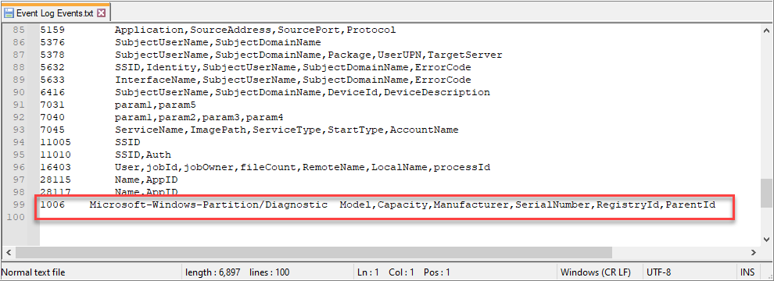

This slide is an example of a Windows log taken from a Windows 10 system. The top breaks out the System Properties section. These are the main fields for every event. The bottom shows the EventData section. This is where custom fields such as NewProcessName are stored. To view the XML of a Windows login, first open Windows Event Viewer and open the log you wish to analyze. The log will have a tab for General and a tab for Details. Click on Details and then switch from Friendly View to XML View.

Field Structure

XML contains mainstream fields

- EventData and UserData are further structured into other XML fields (infinite possibility of fields)
- XML does not require traditional parsing…
  - Older collection methods (syslog) may cause visibility loss
  - For example, logos from 10 Windows devices are likely to have over 500 fields

Use of XML structure provides robust logging capabilities
- Older collection methods (syslog) may cause visibility loss
- For example, logos from 10 Windows devices are likely to have over 500 fields

Use of XML structure provides robust logging capabilities

Microsoft made a smart decision when they decided to add the XML schema capabilities in EVTX files. This effectively allows intelligent, structured logs that can contain more data, yet have more capabilities as far as precision and filtering and concerned. Because EVTX events use XML, an infinite number of fields can be created. This is important to note as traditional log agents will oftentimes parse out the most critical fields. This can result in having approximately 50 to 100 Windows fields to search on. While this simplifies searching and filtering, it is also blinding as there are easily over 500 fields and they may be necessary for certain techniques to work. It is important to know if this is a limitation of your environment. If so, new events with new fields will not be usable until custom parsers are built by your vendor. In this author’s experience, this typically takes three to twelve months unless you are willing to pay for immediate professional services. Oddly enough, since fields are stored in XML, it is possible to auto-parse out all new fields. Yet some products do not support this (often if they are transporting the log over the syslog).

Event Tracing for Windows (ETW)

Windows natively supports system tracing
- Trace logs stored as .etl files
- Provides kernel-level, high-performance monitoring
- Disabled by default due to performance and # of events
- May require disabling in order to view events.
- Potential capability for deep system-level monitoring

Trace files can be standalone or registered to a channel

Microsoft implemented trace logs to provide highly detailed logs that can maintain high-volume logging. These logs are managed by the Event Tracing for Windows subsystem and are stored with a .etl file extension. Typically, these are recommended to be enabled only when needed for troubleshooting and disabled afterward due to performance overhead. When viewing trace logs, it is sometimes required first to disable tracing prior to being able to view the logs. Note that turning tracing back on clears the logs.

Microsoft is inventing more time into providing additional trace logging as well as minimizing the performance impact. For example, starting in Server 2012 R2 and later, Microsoft supports Windows DNS Server debug logging with little to no noticeable impact. Should a Windows DNS Server be running commodity hardware and handling around 100,000 queries per second, the performance impact is expected to be only 5%. In this example, this is the Microsoft-recommended method for performing DNS logging moving forward. While the use cases for regularly collecting and analyzing ETL files are rare, it should be noted that many trace logs exist that may be of use.

Reference:

https://docs.microsoft.com/en-us/windows/win32/etw/event-tracing-portal, https://sec555.com/5g

Channel

“A channel is basically a sink that collects events.”

Channels act as receivers of specific events

- Act as a high-level category

Applications/scripts can define their own channels

- Important for collection
- Event logs require an ID
  - Intended to classify event types
  - Usually unique to the specific channel

When people think of Windows logs, they often envision the Windows Event Viewer. The most common places people look are the Application, Security, and System Logs. These are examples of channels. They are a location for created logs to go to. This is what they mean by a “sink”.

Reference:

https://docs.microsoft.com/en-us/windows/win32/wes/defining-channels, https://sec555.com/5t

Channel Types

Four types: Admin, operational, analytic, and debug

- Admin and operational most common (.evtx)
  - Admin events consist of well-known and documented events
  - Operational events typically used for human analysis
- Analytic and debug often off by default (.etl)
  - Due to the high volume of events generated when enabled
  - Often requires stopping prior to the ability to read events
  - Possible to obtain while running third-party tools

Under the hood, there are four channel types: Admin, operational, analytic, and debug. The purpose of these channels is to describe the type of logs they contain. For instance, admin logs are supposed to be for events that are well documented, and any resolution that is necessary is described in detail.

Event viewer graphically shows what type of channel is being used. See the next slide for more details.

Reference:

https://docs.microsoft.com/windows/desktop/WES/defining-channels, https://sec555.com/5t

Analytic and Debug Logs

Steps:

- Show Analytic and Debug Logs
- Enable Logging

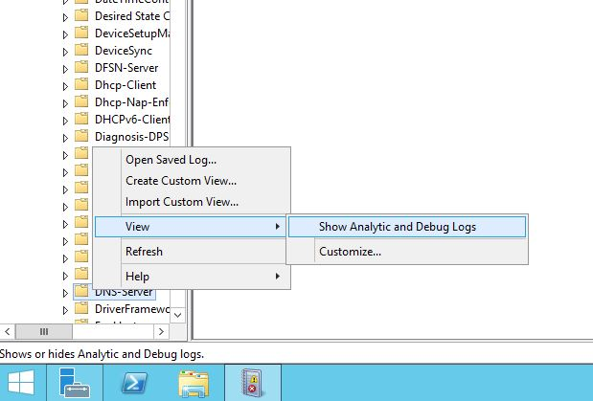

This slide demonstrates how to see and enable debug logs. The right picture demonstrates enabling the DNS-Server Analytical log. If you look closely, you can also see the icons for Audit, Analytical, Debug, and Operational are different. These visually represent channel types.

PowerShell Tuning

Some channels default to off
- Group Policy does not have the option to enable them
- But group policy and asset management tools can invoke PowerShell

Enabling extra logging via PowerShell is as simple as:

$logName = ‘Microsoft-Windows-DriverFrameworks-UserMode/Operational’
$log = New-Object System.Diagnostics.Eventing.Reader.EventLogConfiguration $logName
$log.IsEnabled=$true
$log.SaveChanges()

PowerShell is also great to dynamically tune systems

PowerShell is one of the best things Microsoft has introduced. It opens so many possibilities (both for defenders and attackers). For defenders, it provides a framework for dynamically and/or automatically configuring systems. For example, if there are special log levels that need to be enabled or disabled, PowerShell can handle it. If an application is using a configuration file to manage logging, PowerShell can dynamically alter it based on conditional logic. When all else fails, PowerShell can, on the fly, generate a log event to the Windows event log. More on this in a few slides.

Managing Windows Logging

Windows audit policies control what to log
- Can be defined locally or centrally through group policy

Audit policies are broken down into log categories
- Logging enabled by selecting to log success or failure of an event’s occurrence.

Additional logging = additional overhead

Enabling or disabling Windows logging is done with Windows audit policies. Fortunately, Windows audit policies are not only easy to set, but also easy to understand. Each log category within Windows log policies has a tab labeled “Explain.” When clicked, “Explain” gives an in-depth description of what the policy does. This, combined with the ability to set and deploy audit policies via group policies easily, makes configuring Windows logging easy.

Reference:

https://docs.microsoft.com/en-us/windows-server/identity/ad-ds/plan/security-best-practices/audit-policy-recommendations, https://sec555.com/5u.

Windows Audit Policies

Audit Policy

Basic log settings
- Available for Windows 2000+

Advanced Audit Policy

Provides granular control of logs
- Requires Server 2008-R2 or Windows 7 or later

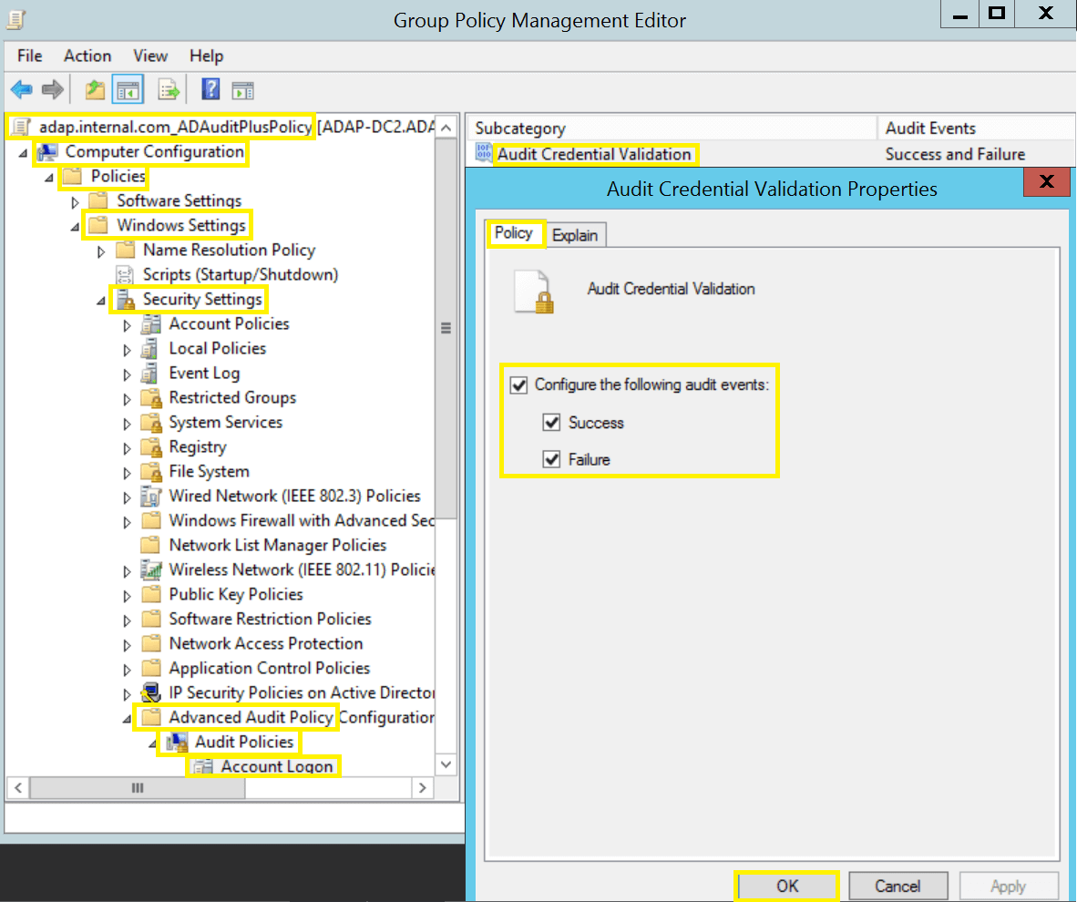

The Windows audit policy is available in two formats: The basic audit policy and the advanced audit policy. The basic audit policy was the only option until Windows 7 and Server 2008 R2. These operating systems introduced the advanced audit policy. This allows for more granular control over what logs are recorded.

Advanced Audit Policy

Default settings prefer audit policy rather than advanced audit policy
- If using advanced audit policy, remember to change this

Computer Configuration > Windows Settings > Security Settings > Local Policies > Security Options

- Enable “Audit: Force audit policy subcategory settings”

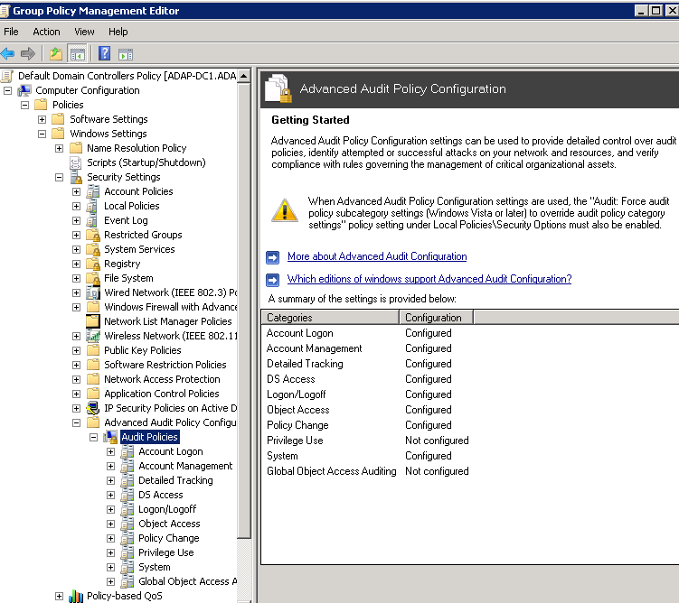

When using the advanced audit policy, it is important to know that the default behavior is for basic audit policy settings to override advanced audit policy settings. Fortunately, Windows warns you of this when you visit the advanced audit policy. Fortunately, Windows warns you of this when you visit the advanced audit policy. It also shows how to change this behavior by setting “Audit: Force audit policy subcategory settings” to Enabled.

Keep in mind that using advanced audit will also clear the simple policy settings.

Reference:

https://docs.microsoft.com/en-us/previous-versions/windows/it-pro/windows-server-2008-R2=and=2008/ff182311 (v==ws.10) #BKMK_3, https://sec555.com/5v.

auditpol.exe

Non-domain joined systems can be configured with auditpol.exe^1
- Can list and set policies
List policy settings:

Auditpol /get /category:*

Set policy settings:

Auditpol /set /subcategory:”file system” /success:enable /failure:enable

Not all systems are typically joined to a domain. Some are intended not to be joined for security purposes (such as DMZ systems). In order to effectively maintain log settings, audit policies need to be pushed out. Since group policy is not available, an alternate method such as using auditpol.exe is needed. This command line utility can retrieve and set audit policy settings. Because of this, it is fairly easy to automate and push out a standardized audit policy for non-domain joined systems.

*Another command that may be beneficial is the one below. It lists out all the available policy categories.

Auditpol /list /subcategory:

Reference:

https://www.ultimatewindowssecurity.com/wiki/page.aspx?spid=SecuritySettings, https://sec555.com/5w.

CIS Benchmarks

The Center for Internet Security (CIS) provides free benchmarks

- Used to evaluate and implement security baselines
- Recommends audit policy settings
  - More importantly, explains why
  - May place emphasis on denial of service via logging
- Recommendations are suggestions – tune to your environment after reading CIS reasoning

In order to tactically detect things, logs must be first collected. In Windows, this means an effective audit policy needs enabling. The problem quickly becomes, “What settings should I set?” One of the quickest ways to find recommendations on audit policies need enabling and why is to read the CIS Benchmarks based on Windows^1. These benchmarks include baselines for securing Windows operating systems and other Windows programs like Internet Explorer and SQL Server.

Where CIS benchmarks shine is that every setting includes a detailed breakdown of what it does, why it is important, and why the recommendation is for certain settings. This is great for understanding what the impact of a specific setting is. In fact, the details provided are considerably better than the description provides under Group Policy Management. Some of the additional information provided includes the specific event IDs generated, the vulnerability and impact of enabling or disabling the policy, and suggested countermeasures. The recommendations provided are generally acceptable. However, consideration should be given to your environment and collective settings. For example, there are some events for which you may want to record both successful attempts and failures, yet the recommendation is for success only. Logoff events are one example where the recommendation is to only record successful logoff attempts. The reasoning is that the setting provides an attacker the ability to generate millions of failure events. If the “Audit: shut down system immediately if unable to log security audits” is enabled, this can grant attackers the ability to perform a denial of service attack. If this setting is off, you instead run the risk of logs stopping once full or of logs constantly being rotated if “Overwrite events as needed (oldest events first)” is set. “Overwrite, events as needed” is the default behavior.

Reference:

https://www.cisecurity.org/benchmark/microsoft_windows_desktop, https://sec555.com/5x.

Account Management

Used to track changes to groups, users, and computers
- Needed to monitor key groups for modifications
- Such as new members added to Domain Admins

Powerful when combined with Change Control system

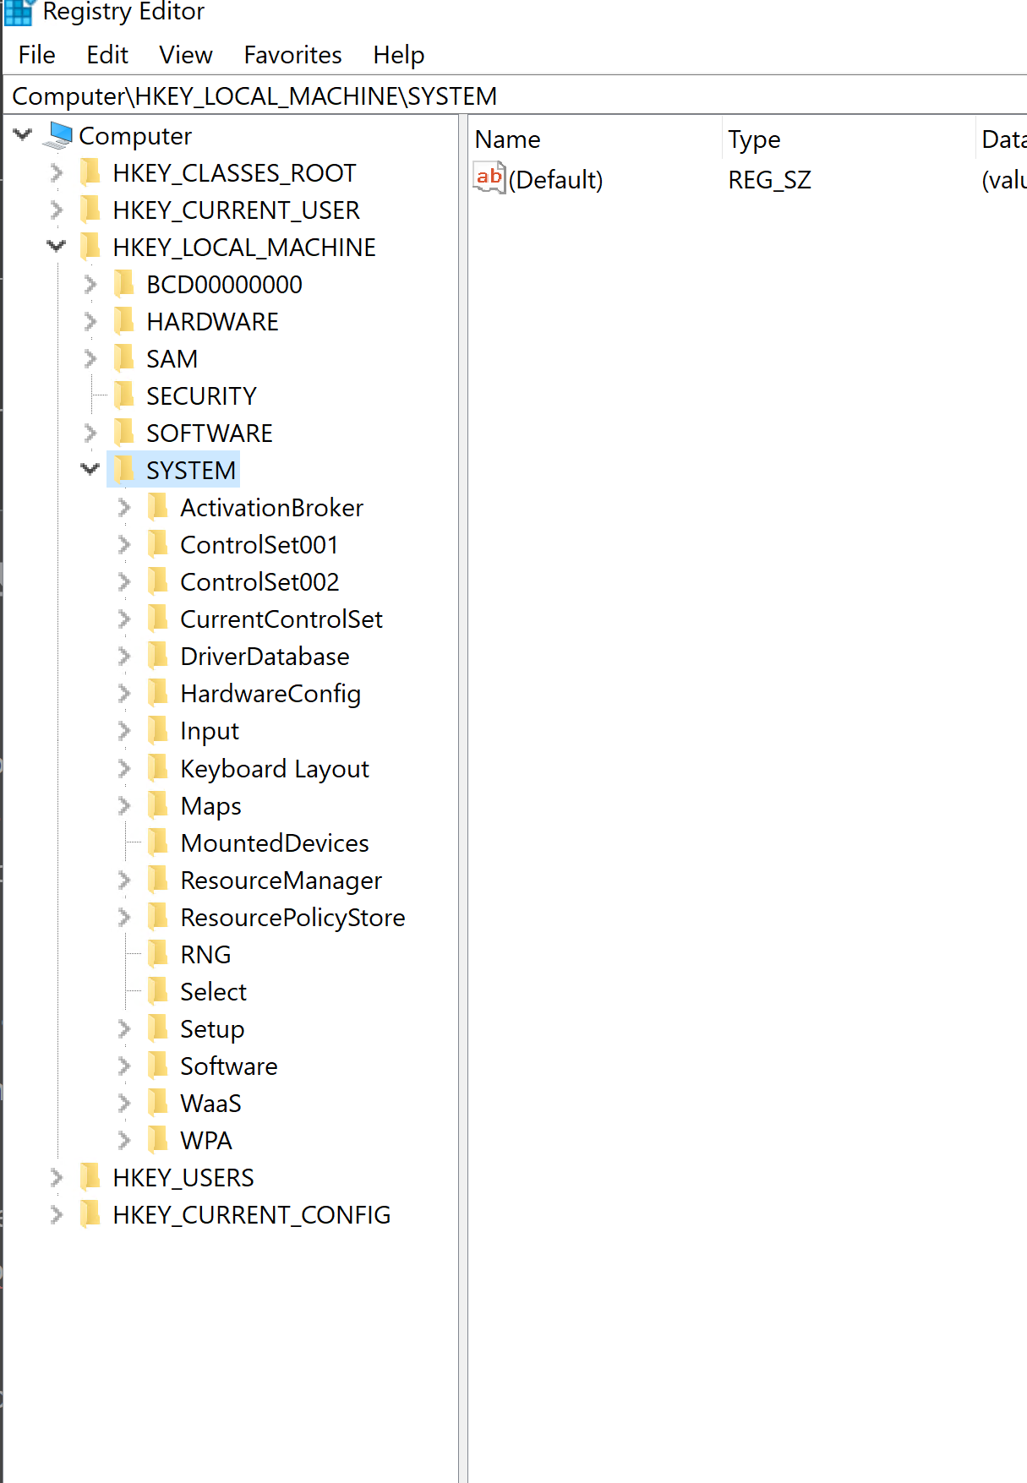
These types of events are useful to keep track of unauthorized changes. For example, it is a best practice to monitor additions to any sensitive security group such as Domain Admins and Enterprise Admins.

Powerful when combined with change control system.

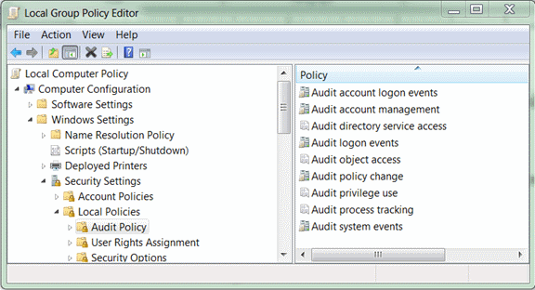

These types of events are useful to keep track of unauthorized changes. For example, it is a best practice to monitor additions to any sensitive security group such as Domain Admins and Enterprise Admins. While out of the gate something such as monitoring Domain Admin additions are high value, more can be achieved if logs from a change control system can be used to verify security group changes.

For example, if employees are added to a group called Sensitive Data access, hopefully, it required someone to authorize the addition. If the authorization record can be used, it can be verify that all modifications came with prior consent. Then, should an adversary add an account to this group, it would be red-flagged as no prior authorization was given.

Audit Application Group Management: Monitors changes to application groups. Application groups are used to tie roles using Windows Authorization Manager.

Audit Computer Account Management: Monitors changes to computer accounts.

Audit Distribution Group Management: Monitors changes to Active Directory distribution groups. While this can record details about groups being modified such as Domain Admins, it is not needed.

Audit Other Account Management Events: Monitors special changes such as a password hash of a user account being accessed or changes to the password policy or lockout policy.

Audit Security Group Management: Monitors changes to standard security groups.

Audit User Account Management: Monitors changes to user accounts.

Audit Distribution Group Management: Monitors changes to Active Directory distribution groups. While this can record details about groups being modified such as Domain Admins, it is not needed. The Audit Security group Management records more information that is helpful and specific.

Audit Other Account Management Events: Monitors special changes such as a password hash of a user account being accessed or changes to the password policy or lockout policy.

Audit Security Group Management Events: Monitors changes to standard security groups.

Audit User Account Management: Monitors changes to user accounts.

Logon/Logoff:

Many attacks involve credential theft and reuse
- Therefore, tracking logons is critical.
- Too many failed login attempts show brute forcing, misconfigurations, or password spraying.

Too many successful logons means the end is near…
- Or that legit credentials are being used to crawl the network

One of the least detected attacks that are highly prevalent is credential theft. In fact, Mandiant, a major incident handling company, stated in an annual M-trends report that 100% of their investigations involved credential theft and reuse. This trend still holds true for both malicious compromise and bought and paid for penetration testing.

Monitoring logons is a critical component in continuous monitoring. At the most basic level, organizations should look for repetitive login failures or successes to find brute force attempts or compromised accounts spreading internally. Once this and other high-value quick wins are implemented, then organizations should advance their monitoring to include things such as baselining user activity by monitoring logins, logoffs, times of occurrence, and systems typically logged into per user. This is an area where machine learning has greatly improved and could be of value. Baselining is covered in more detail in Section 4.

Audit Account Lockout: This records both successful and failed logins when a login request is made against a locked-out account.

Audit Logoff: This records both successful and failed logoff attempts. This is useful for context. For instance, was user XYZ still logged in at the time of an incident?

Audit Login: This records successful and failed login attempts. Failed login attempts are useful for catching brute force attempts, and successful login attempts are great for profiling user activity or finding credential theft. This may manifest as credentials being used during abnormal hours or creating large numbers of sessions.

Audit Other Logon/Logoff Events: This records successful and failed logon/logoff events for things such as terminal service or screen saver sessions.

Audit Special Logons: This records requests to log on for accounts added to special monitored groups. For this policy to be effective, you must find the SID of any groups to be monitored and add them to HKEY_LOCAL_MACHINE\System\CurrentControlSet\Lsa\Audit\SpecialGroups. This key does not exist by default and should be set to string. For more information, see KB article 947223.

Reference:

https://techcommunity.microsoft.com/t5/ask-the-directory-services-team/special-groups-auditing-via-group-policy-preferences/ba-p/395095

Detailed Tracking

Can generate vast amounts of logs – proceed with caution

- Has built-in monitoring of processes
  - Default behavior does not include command line logging
- Windows 10/Server 2016 also includes plug and play monitoring

Be careful when enabling logs under detailed tracking as they may have performance implications. However, there are a few critical events analysts should regularly monitor. One is process creations, which involves logging all processes being launched. Windows can natively log this if Audit Process Creation Policy is enabled. These types of logs can also be collected from application control suites. It is important to note that the default behavior of Audit Process Creation is to generate an event on each new process being launched but that it does not include any command line parameters involved with the process starting. To enable auditing process creation and include command line parameters, enable “Audit Process Creation” but also enable the policy “Include command line in process creation events” located at Computer Configuration > Policies > Administrative Templates > Audit Process Creation.

Another thing worth tracking is new devices being plugged in, such as plug and play devices. Starting with Windows 10 and Server 2016, Microsoft allows logging of plug and play devices. While this, unfortunately, is not available for older operating systems, it is a step in the right direction.

Object Access

Object access is one of the most misunderstood settings

- Such as audit file system… it does not log all file access

Object access controls log for quite a few things. If you wish to audit files, registry keys, or network shares, you must enable the auditing capability first. For example, after turning on Audit File System, it grants Windows the ability to audit things like files or folders being accessed, but only if an ACL is placed on them telling what to audit. In the past, there was a wide misconception that enabling this would generate an event for every file accessed.

This audit policy also controls things such as Windows Firewall logging to a log channel and file access on removable drives. In Active Directory, many things are considered objects (users, groups, files, folders, registry keys, etc.). This policy even controls certificate-related events.

Additional Windows Logging

Sometimes, additional logging is necessary or recommended.

This can be achieved through:

- Writing and using PowerShell scripts
- Developing custom applications, drivers, or services
- Installing third-party programs
  - A common and free program that provides additional logging is Sysmon^1 by Windows Sysinternals.

With each version of Windows, the logging capabilities are getting better and better. Yet there are still things that Windows does not natively log. Should you need additional logging, this can be handled by writing custom scripts or programs or often it is handled by purchasing a custom product and implementing it. One reason for the trend toward commercial products is that they provide support for their products, and they market them. Yet there are free alternatives such as Sysmon ^1 or writing custom scripts. These solutions often provide immense amounts of useful information and are a lot easier to maintain than one would think.

Reference:

https://docs.microsoft.com/en-us/sysinternals/downloads/sysmon, https://sec555.com/5y.

Custom Logging with PowerShell

PowerShell makes writing custom logs easy

- Simply use Write-EventLog to generate a custom log
- If you want a custom channel, first, use, New-EventLog

New-EventLog -LogName MyCustomLogs -Source “MyPSLogger” -EventId 31337 -EntryType Warning -Message “Sec555 is too cool to handle”

Can be used to generate logs that even basic log collectors can collect

- May remove the need for special log agents

One of the easiest ways to generate a custom log is to use PowerShell. PowerShell, in itself, is powerful and can do just about everything. Taking that functionality and adding a simple function to create logs opens the door to all sorts of opportunities. Let’s say, for instance, you have a program that only outputs logs to a file, yet the log agent or collection method you have at your disposal does not handle files well. To resolve this, you could write a PowerShell script that monitors the log file and turns it into Windows event logs.

Another example would be if you had a recurring task that you would like to log. Instead of outputting to a log file, simply dump data into an event log channel. Since PowerShell also has the capability to create a new channel as well as specify custom Event IDs, logs become easy to read and sort. If you are planning on using a custom event log, you must create it using New-EventLog. Failure to do so will result in an error and no log being generated when invoking Write-EventLog. Write-EventLog even works in older operating systems such as Windows XP.

Important note: Windows task scheduler, starting in Windows Vista, has the capability to kick off a task based on a Windows Event ID being generated. This can be combined with custom logs to trigger actions or could be used to monitor an event where the description does not provide sufficient detail. When that event triggers, a task can execute to gather information and create a custom event with the relevant information.

PowerShell-Generated Log

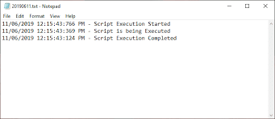

This slide shows the creation of a new event log channel called MyCustomLogs, as well as a single log generated from the commands on the previous slide.

Sysmon

Free download from Windows Sysinternals
- Written by Mark Russinovich and Thomas Garnier
- Runs as a Windows system service and device driver
- Monitors:
  - Processes
  - Network connections
  - Driver and DLL loading
  - Registry key modification
  - Modification of file creation times
  - Process access
  - WMI Monitoring
- Provides process hashes and parent processes for analytics

Sysmon was designed to generate logs of interesting activity commonly associated with malicious or anomalous activity. By themselves, the logs are useless; however, when looked at by an analyst, they can be extremely powerful. For example, Sysmon can monitor all processes being launched along with the parent process that spawned the new process and can provide a hash of the new process. On top of this, the log also includes any command line parameters along with other useful information. Collecting this data centrally and evaluating it lets you know exactly what exactly is taking place in your organization.

Similar to NetFlow, Sysmon can optionally log all network connections being made. However, unlike NetFlow, Sysmon records the process that either made the network request or is receiving the network request. This level of detail is great for troubleshooting, incident response, and establishing firewall rules for a default deny policy.

Under the hood, Sysmon utilizes built-in API calls and ETW tracing to generate logs. This allows for minimal performance overhead. Keep in mind it will generate a lot of logs. This author likes to see Sysmon installed on all systems so that the logs are there if needed. However, it may not make sense to try and collect all of these logs centrally unless major filtering is done. Sysmon allows fine-grained filtering on what not to log. For example, you can create a configuration rule to log all network connections unless they come from the process iexplore.exe.

Sysmon is built for both desktops and servers. It can be deployed to Windows 7 and newer as well as Server 2012 and newer operating systems. Mark Russinovich wrote a presentation for RSA Conference 2016, which does a great job explaining Sysmon, its use cases, and how to configure it.

References:

https://docplayer.net/19532221-Tracking-hackers-on-your-network-with-sysinternals-sysmon.html, https://sec555.com/5z.

Sysmon Example

In this slide, the parent process of C:\Windows\System32\cmd.exe is running the batch script at C:\Program Files\Intel\SUR\WILLAMETTE_svc_install.bat. This is being executed by the NT AUTHORITY\SYSTEM account, and a hash of the executable being spawned (C:\Windows\System32\timeout.exe) is provided.

Collecting this level of detail allows for studying and understanding what is happening in your environment. For example, if you received this log, would you know what WILLIAMETTE is? It sounds odd; possibly it is malicious, but it is in the C:\Program Files\Intel folder so maybe it is not. Investigating this would reveal it is an Intel service for providing power savings and is installed as part of the Intel Driver Update Utility.

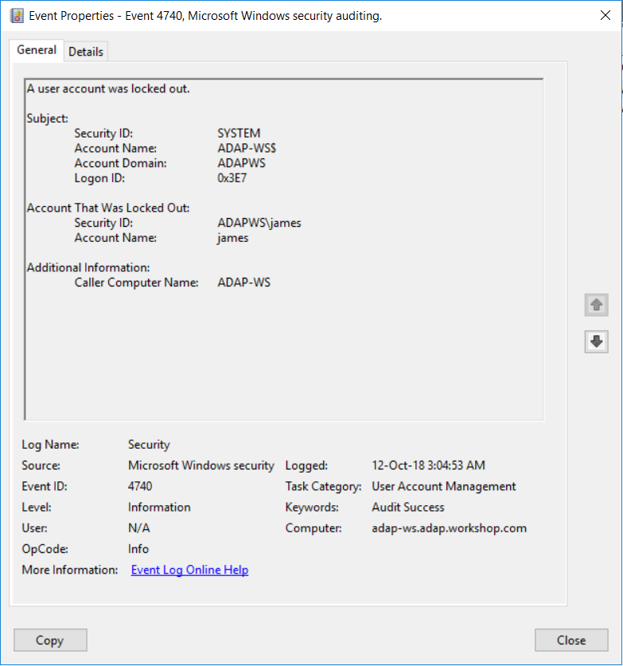

Sysmon Configuration

Granular logging available

- Uses XML config
- Can include or exclude on:
  - Path
  - Process/Image
  - Digital Signature
  - Integrity Level

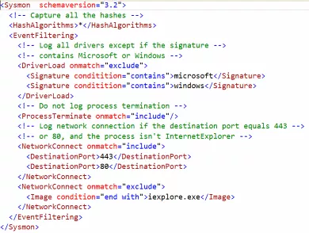

Configuring Sysmon to log or not log something can be done with basic command line switches or by using the advanced configuration. The advanced configuration requires the use of XML configuration files. When deploying Sysmon, it is usually recommended to use the advanced configuration files as the level of granularity is often used to include or exclude things.

The following commands can be used to find more information on building a Sysmon configuration:

Sysmon.exe –help
Sysmon.exe -? Config

The picture in this slide also shows an example of a functional XML configuration file used for Sysmon version 5. The main thing to pay attention to is the use of onmatch = “include” and onmatch=”exclude.” In the case of onmatch = onmatch=”exclude”, all items are logged except for the ones specifically excluded. So, a statement reading <ProcessCreate onmatch=”exclude”></ProcessCreate> would log all process creations as no exclusions are specified. In contrast, onmatch=”include” only includes items specified. The configuration of <ProcessCreate onmatch=”include”></ProcessCreate> would log nothing because nothing is specified to be included for logging.

If attempting to build a new Sysmon configuration, consider using a community-provided configuration for a starting point.

Reference:

https://github.com/SwiftOnSecurity/sysmon-config, https://sec555.com/60

Sysmon Modular
Project by Olaf Hartong

- Adds MITRE tags
- Modular design
- Easy to support

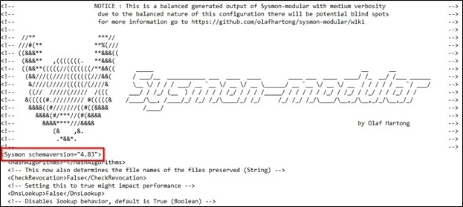

Olaf Hartong supports a GitHub project called Sysmon Modular. Sysmon Modular provides a breakout of each Sysmon functionality into subfolders. The subfolders contain inclusion and exclusion configuration files which also include MITRE technique information. Having multiple configuration files that are based on each capability of Sysmon simplifies organization to support and maintenance.

Deploying Sysmon Modular requires running a PowerShell command that combines all the individual configuration field into a single XML configuration. Installing Sysmon or updating it requires running sysmon.exe and referencing the generated XML configuration file.

Reference:

https://github.com/olafhartong/sysmon-modular

Windows Logging Summary

Windows logs come in multiple formats
- EVT, EVTX, and ETL

Current operating systems use EVTX, which is XML-based
- This allows for unlimited fields and granular logs

What gets logged is controlled by audit policies

Custom logs can be created by software or scripts, such as with PowerShell

Windows logging is simple and complex. This is because there are multiple formats of event logs and logs can be granular. For proper design, audit policies must be deployed to enable or disable Windows events.

Linux Logs

Syslog is the primary method of logging for Linux/Unix
- The default behavior is to listen using a local socket

Multiple syslog daemons exist
- Default log location is /var/log
- Filenames such as auth or kern specify log category
- Log level specified by severity in daemon configuration
- Daemon can be configured to accept and to send logs

In comparison to Windows logging, Linux logging is substantially different. This adds to the challenge of system administration as different platforms require different administration. In the case of Linux, syslog is the default logging service, and even then, there are multiple flavors of syslog in use today.

The default behavior of most systems is to log to /var/log, and filenames such as auth.log are specified to categorize the log. This is also referred to as the syslog facility in many cases. By default, most syslog services, also called daemons, only log facilities. However, they can be modified to ship logs over the network or even accept logs from other network systems.

Common Log Files

/var/log/messages - Global messages (general activity)
/var/log/auth.log - Authentication-related logs
/var/log/boot.log - Boot time events
/var/log/daemon.log - Kernel messages (often used for troubleshooting)
/var/log/kern.log - Kernel messages (often used for troubleshooting)
/var/log/cron.log - Events related to scheduled tasks
/var/log/secure - Events related to su or sudo access

This slide lists out some of the more common log files found on Linux operating systems. Where Windows uses channels, Linux uses filenames to categorize events. Linux applications will also often log to /var/log but do so in a subfolder. For example, MySQL typically stores logs in /var/log but do so in a subfolder. For example, MySQL typically stores logs in /var/log/mysql and Apache usually uses /var/log/apache2/.
Facility and Severity Output

Facility (0-23)

- Kernel, user, mail system, system daemons, security/auth, FTP daemon, NTP, log audit, log alert, clock daemon, local use (0-7)

Severity (0-7):
- Emergency: system is unusable, alert: action is needed, critical: critical conditions, error: error conditions, warning: warning conditions, Notice: normal but insignificant, Informational: informational messages
- Debug: debug-level messages

Syslog uses the facility to describe what a log is for. Custom applications often use local use 0 through 7. Severity is used to describe the importance of a log.

Facility

Per RFC 5424:

Numeric Code Facility

0: kernel messages
1: user-level messages
2: mail system
3: system daemons
4: security/authorization messages
5: messages generated internally by syslogd
6: line printer subsystem
7: network news subsystem
8: UUCP subsystem
9: clock daemon
10: security/authorization messages
11: FTP daemon
12: NTP subsystem
13: log audit
14: log alert
15: clock daemon (note 2)
16: local use 0 (local0)
17: local use 1 (local1)
18: local use 2 (local2)
19: local use 3 (local3)
20: local use 4 (local4)
21: local use 5 (local5)
22: local use 6 (local6)
23: local use 7 (local7)

Severity

Per RFC 2454:

Numeric Code Severity

0 - Emergency: system is unusable
1 - Alert: action must be taken immediately
2 - Critical: critical conditions
3 - Error: error conditions
4 - Warning: warning conditions
5 - Notice: normal but significant condition
6 - Informational: informational messages
7 - Debug: debug-level messages

Reference:

https://www.ietf.org/rfc/rfc5424.txt, https://sec555.com/72

Syslog Config Example (Ubuntu 16.04 System)

auth,autpriv.*
authpriv.=warning
*.*;auth,authpriv.none
Cron.warning
*.!info
kern.*
#lpr.*
mail.*

/var/log/auth.log
@10.5.55.10
~/var/log/syslog
/var/log/cron.log
/var/log/verbose.log
~/var/log/kern.log
~/var/log/lpr.log
~/var/log/mail.log

This example is from the default Ubuntu 16.04 syslog configuration file. The traditional syslog format is compatible with the newer syslog format. This example follows what gets logged and where. The left column specifies the facility and severity levels to log, and the right column specifies the destination.

Auth, authpriv.* /var/log/auth.log

This takes any logos with a facility of auth or authpriv and sends them to /var/log/auth.log. The asterisk referenced means all severities.

authpriv.=warning @10.5.55.10

This takes any logs with a facility of authpriv and a severity of warning and sends them over UDP port 514 to 10.5.55.10. The equals sign specifies an exact match on severity, so only a severity of warning will be included.

cron.info /var/log/cron.log

This takes any logs with the cron facility that have a severity of info or higher and writes to var/log/cron.log.

*.!info /var/log/verbose.log

This takes any logs with any facility that have a severity of info or lower (which would include info and emergency severities) and writes them to /var/log/verbose.log.

Cron.warning /var/log/cron.log

This takes any logs with a facility of cron and a severity of warning or higher (error, critical, alert or emergency) and sends them to /var/log/cron.log

kern.* ~/var/log/kern.log

This takes any logs with a facility of kern and with any severity level and sends them to /var/log/kern.log. The dash before /var/log/kern.logmeans that syslog does not have to flush the log to disk after each log. This is often used for log field that receive a lot of logs. Having to confirm the write to disk could cause unacceptable performance issues. However, should a system crash with this setting enabled, it is possible that logs may not have been committed to the log file and thus, can be lost.

Syslog

Originally developed in the 1980s by Eric Allman

- Initially was designed for sendmail

Limited feature set

- Basic output options such as console, file, and remote
- Facility use to classify logs and severity used to define log level
- Syslog often used by network devices
- Typically, only supports UDP transport (default port 514)

Modern systems use rsyslog or syslog-ng

Syslog first made its appearance back in the 1980s. Originally, it was designed to log on behalf of sendmail, a popular email daemon. However, the security community quickly saw its potential and began to adopt it for other things. Like many projects with quick adoption, it has changed over time. At its basic configuration, syslog is used to log messages to disk. For example, login attempts get stored in /var/log/auth.log. Should these need to be sent to a remote logging host, the standard syslog daemon allows network transportation over UDP port 514. The original syslog service did not support TCP, SSL, or TLS.

References:

http://www.liquisearch.com/syslog/history, https://sec555.com/61

https://www.syslog-ng.com/products/open-source-log-management, https://sec555.com/62

Syslog Example (when transported over network):

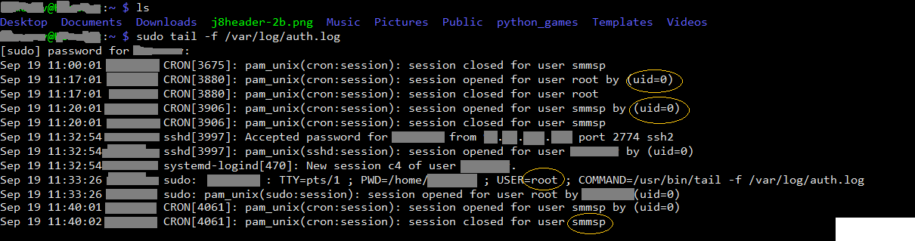

/var/log/auth.log example:

Jan 4 14:43:13 logparse sudo: jhenderson: 1 incorrect password attempt; TTY = pts/1;
PWD = /var/log; USER=root; COMMAND=/bin/su

This slide represents a failed login stored in /var/log/auth.log of an Ubuntu 16.04 system. Notice the difference is minor between syslog on disk and syslog over the network. On disk, the log facillity/category is identified by the filename of auth.log. Over the network, this is identified using the syslog PRI field, which is the beginning of the filename of auth.log. Over the network, this is identified using the syslog PRI field, which is the beginning of the filename of auth.log. Over the network, this is identified using the syslog PRI field, which is the beginning <81>. The integer in this field comprises the facility and severity for the log. To find the facility and severity, a math formula must be applied. The math formula for the PRI field will be described in a few slides. Note that /var/log/auth.log does not have anything that describes the severity (debug, info, warning, etc.). This is because the default behavior of rsyslog on Ubuntu 16.04 is to place all severity types for the facility auth into /var/log/auth.log.

Syslog Breakdown

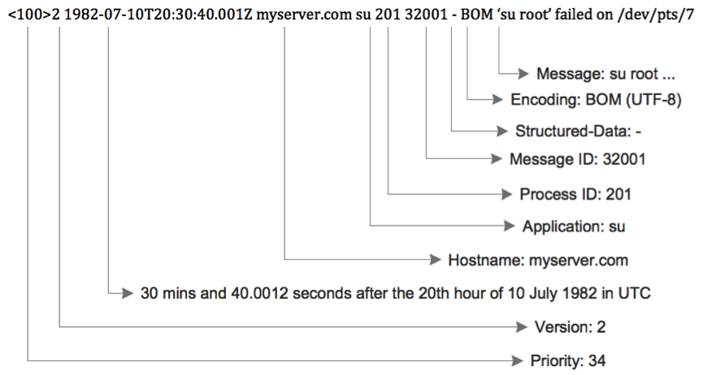

Syslog messages sent over the network typically consist of five main fields. The PRI field starts at the beginning and is an integer that is calculated to store the facility and severity label for an event. Following this is the timestamp that’s specific to the system generating the event. If the source system’s time is off, then this timestamp will be incorrect. It is also important to note that the timestamp is specific to the time zone of the source system. This will need to be accounted for if an organization contains systems across multiple time zones. After the timestamp is the source hostname, followed by the source program that generated the event log. Finally, the message contains the specifics of the log. Unlike Windows, Linux does not generate a unique event ID specific to an event. This often requires string searching or adding fields or tags to report on specific events such as logons. To garner value, the message field often requires further breakdown and parsing. This is primarily because syslog does not use structured schemas such as XML. This, combined with the freedom available to programmers on how the message field is used per program, causes a lot of extra labor to make sense of Linux logs.

Syslog PRI

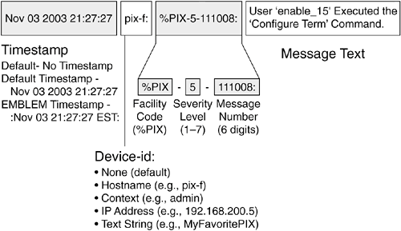
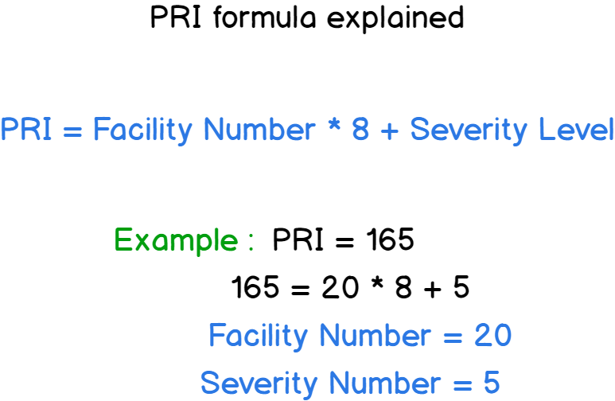

A new analyst looking at a raw syslog message often tends to ignore the syslog PRI field, thinking it is just noise in the log. This is because it looks out of place. For example:

<81> Jan 4 14:43:13 logparse sudo: jhenderson: 1 incorrect password attempt; TTY = pts/1; PWD = /var/log; USER = root; COMMAND = /bin/su
The <81> looks like it may just be a random number tacked to the front of the log. However, it is the syslog PRI field. This field is an integer that can be mathematically reversed into the numeric facility and severity codes. The math formulas on this slide show how to reverse the integer into the proper codes. In the example of <81>, the facility would be 10, which is the facility code for security/authorization. The severity would be 1, which is the severity code for the alert.

Syslog-NG

One common Linux syslog daemon is Syslog-NG^1
- Capable of handling 600K+ messages a second
- Enhanced with many filtering and custom parsing capabilities
- Contains many output modules
  - Such as Elasticsearch, AMQP, and Apache Kafka
  - Supports transport over TCP, UDP, SSL, and TLS

Configuration file does not conform to syslog format
- The format is clean and easy to read unlike syslog format.

After syslog came Syslog-NG. It was designed by the community to address deficiencies such as the lack of TCP, SSL, and TLS in standard syslog and was one of the first implementations around central log collection. The biggest change for those switching to Syslog-NG from syslog or rsyslog is that it requires its own syntax as it has stepped away from the old syslog format. Like many open-source projects, Syslog-NG has adapted over time, and in its current release, has many capabilities. In modern versions, Syslog-NG is able to collect, parse, and filter logs to many different locations. For example, it can be used to send logs directly into an Elasticsearch cluster. However, parsing performance is not as fast as some of the alternative solutions available today. Though, if parsing is being done system-by-system, this may not be a big deal.

Reference:

https://www.syslog-ng.com/products/open-source-log-management, https://sec555.com/62.

Rsyslog

Rsyslog stands for rocket-fast system for log processing
- Supports original syslog configuration format
- Handles 1 million+ messages per second to local destination
- Contains many capabilities and features similar to Syslog-NG
  - However, performance is faster, especially with filtering and parsing. ^2
  - Yet syntax can be hard to read and write

Supports a highly reliable transport method called RELP (Reliable Event Logging Protocol)

Ryslog is another syslog alternative found in modern Linux systems. A core principle of rsyslog is that it is built for speed. This means even extra functionality, such as parsing is analyzed and modified to make it fast as possible. Logs without parsing can achieve speeds of over a million logs a second. Yet even with parsing, rsyslog is insanely fast. Both rsyslog and syslog-ng are great examples of community-maintained projects. Over time, these projects have gone from local and remote systems to full-blown log agents and parsers. Rather than installing a third-party log agent, these services can be configured to collect logs and transport them where they need to go. This allows for log collection and parsing without the performance and maintenance overhead of additional software. However, the benefit of collection without an agent must be weighed against the ability to use a standard configuration for third-party agents across multiple platforms. One interesting aspect of rsyslog is that it has some special parsing capabilities. It uses the library liblgnorm (as opposed to regex) to perform string searches to look for pattern matches. When this is utilzied instead of regex, parsing is done at minimal overhead and can sustain high events per second. This is often paired with pre-saved pattern lookups, such as for a Cisco switch, to automate parsing while keeping performance a top priority.

References:

https://www.rsyslog.com, https://sec555.com/63
https://rainer.gerhards.net/2013/01/performance-of-liblognormsy-parse.html, https://sec555.com/64

Additional Logging

Similar to Windows, there are third-party programs that can provide additional logging
- Linux Auditing System^1: An access monitoring and accounting system maintained by Red Hat
- Snoopy Logger^4: A command line logging tool
- Scripting can also be used to create logs

Other third-party programs exist

When default Linux logs are not enough, there are options to increase logging. Probably the most common logging tool is the Linux Auditing System developed by Red Hat. Other tools, such as Snoopy Logger, provide logs of every command line entered.

References:

http://linux.die.net/man/8/auditd, https://sec555.com/65
https://github.com/a2o/snoopy, https://sec555.com/66

auditd

Provides a customizable Linux Auditing System

Monitors:

- File access, system calls, program execution, file changes, security events (such as failed logins), network access

Granular monitoring allows advanced use cases
- Also, adds complexity and performance overhead

The Linux Audit system, also referred to as auditd, is maintained by Red Hat but is supported and available to install on just about every Linux system, such as Ubuntu, CentOS, etc. Similar to Sysmon, this service provides additional logging such as recording user activity and process activity. To be truly effective, auditd must be configured and told what to log and what not to log. Some Linux systems come with auditd installed but usually with logging disabled. This is because the level of logging can be immense and cause performance issues. With a little care, auditd can be configured to log only under specific use cases. Unfortunately, the syntax of auditd can be difficult to understand and use. However, because of the granularity allowed, administrators can fine-tune exactly what gets logged. There are multiple community provided auditd configurations. For example, Florian Roth provides an auditd configuration file that is a great start for organizations.

References:

https://access.redhat.com/documentation/en-US/Red_Hat_Enterprise_Linux/6/html/Security_Guide/chap-system_auditing.html, https://sec555.com/67

https://gist.github.com/Neo23x0/9fe88c5979e017a389b90fd19ddfee, https://sec555.com/68

Audit Example

PID is process ID of executable, PPID is for parent process, UID is user ID of the user, AUID is the audit user ID (tracks actions against login even if the user changes with su or sudo)

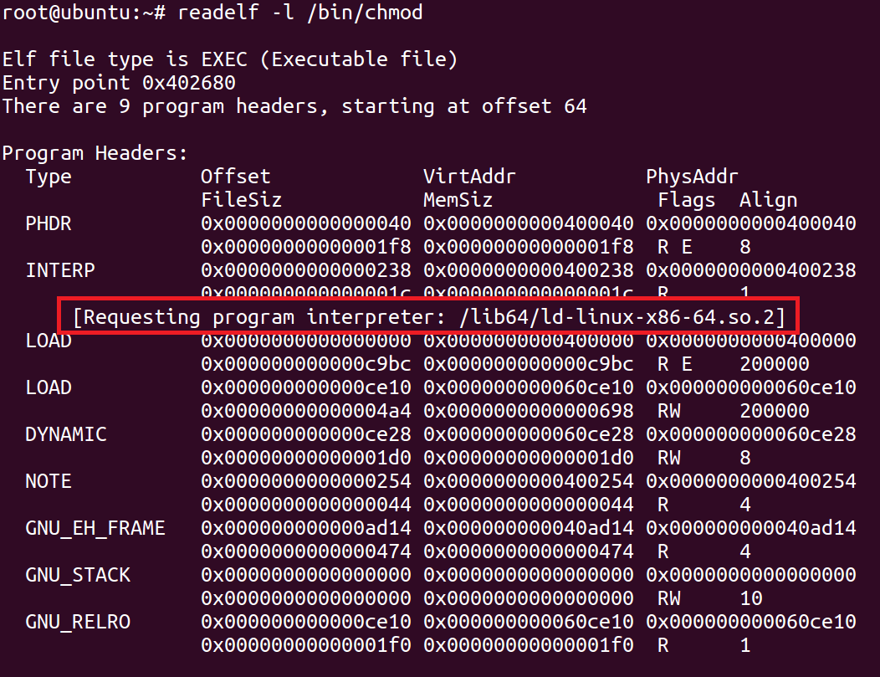
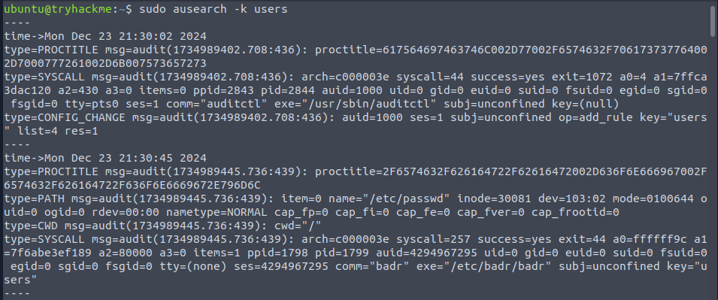

Here’s a breakdown of the events and logs:

- The user with a user ID of 1,000 logs into the system.
- This user then runs the command “ifconfig”.
- Auditd generates the first log in this slide. It contains auid=1000 uid=1000 gid=1000. The auid is a generated ID associating all session activity back to the original user, which, in this case, is the user ID of 1000.
- The user with a user ID of 1000 then changes user accounts by running sudo su. This makes them root. Root has a user ID of 0.
- This user then runs the command “ifconfig”.
- Auditd generates the second og on this slide. It contains auid=1000 uid=0 gid=0. This shows that the action was performed as root (uid=0); yet the session and subsequent actions are actually from user ID 1000. This can be traced by looking at the matching auid field.

Audit.rules Example

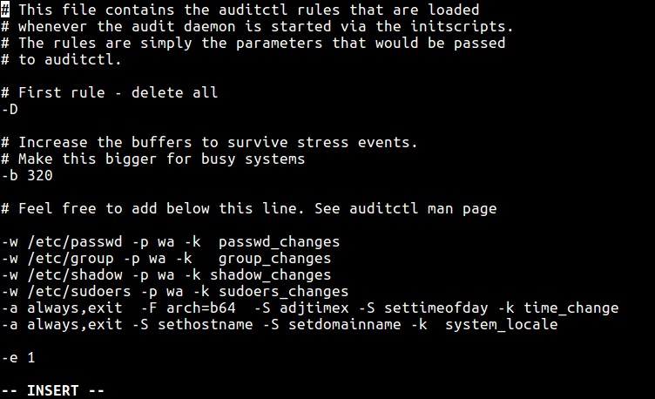
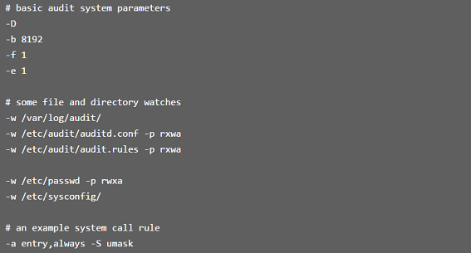
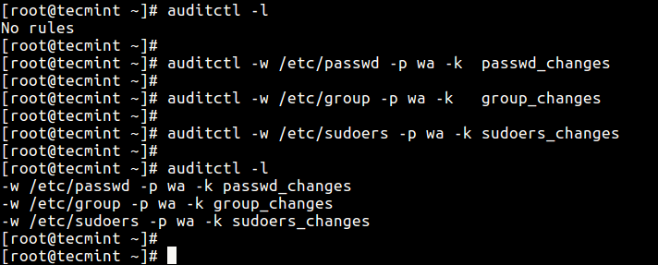

Snoopy Logger

Designed to log command line entries to syslog
- Snoopy maintainers: “Snoopy is not a reliable auditing solution. Rogue users can easily manipulate environment to avoid logging by Snoopy” ^1

So worthless to enable?
- Beware of the perfect fallacy solution
- This can ultimately lead to catching an adversary

More on command line logging to be covered..

The Snoopy Logger is a tiny library that, when installed, logs, executed commands. This can be used to see what is being executed on a system. Ironically, the maintainers of Snoopy publicly state that it can be easily bypassed by rogue users. This does not mean it is not of value. Can an adversary or user bypass it? Yes. Will they always know to bypass it? No. One of the prominent goals in a tactical SIEM is to lay down so many possible tripwires that even if one is avoided another will be triggered. Put another way, even a SIEM has defense-in-depth and multiple layers. While one or many may be bypassed, it only takes one successful tactic to catch the bad guys.

Reference:

https://github.com/a2o/snoopy, https://sec555.com/66.

Sysmon for Linux

Open-source system monitor tool developed to collect security events from Linux environments
- Uses eBPF (Extended Berkeley Packet Filter)
- Transports logs via Syslog
- Utilizes same Event IDs as Windows allowing for easy integration and correlation within the SIEM.
- Possible replacement for Auditd

Developed by Sysinternals and released on the 25th anniversary of Sysmon 1.0 October 14th, 2021. Since the windows and Linux versions share the same manifest, all events will have the same fields when shipped to the SIEM allowing for better correlation and consolidated configuration.

The articles below explain the installation and operational process.

References:

https://in.security/2021/10/18/getting-started-with-sysmon-for-linux/
https://medium.com/@olafhartong/sysmon-for-linux-57de7ca48575.
https://www.activecountermeasures.com/hunting-for-persistence-in-linux-part-1-auditd-sysmon-osquery-and-webshells/

Windows vs. Linux Logs

Windows

Many desktops and servers

- Proprietary logging
  - EVT, EVTX, ETL

Logging control

- Group Policy or Local Policy
- PowerShell
- Use of Sysmon or other applications

Linux

Mostly servers and cloud hosting
- Syslog logging

Logging control
- Syslog configuration
- Scripting
- Use of Audit or other applications

Both Windows and Linux systems have different approaches to logging. Windows utilizes a proprietary log approach, and to no surprise, Linux has adopted an open-source approach. Both have strengths, and both have weaknesses. Windows logs allow for a more precise structure due to using XML schemas, and central management of Windows logging is simple with group policy. Yet, native Windows systems do not have log agent-like capabilities such as parsing and custom output modules.

Linux logs are intended to conform to community standards but sometimes are open to an application author’s whims. Because of the lack of the structured format, syslog logs and their corresponding fields can be limited. Yet, most modern Linux systems can use syslog not for logging but for customization, parsing, and much more. In regard to centralized management, Windows clearly wins although there are multiple ways to centrally manage Linux such as through scripts, configuration management tools like Puppet, and more.

Linux Logging Summary

Logs in Linux are significantly different than Windows
- Syslog is the standard format for logs.
- Built-in syslog agents such as rsyslog and syslog-ng are common in modern operating systems

Open-source applications are available to extend or add logging capabilities such as:
- auditd
- Snoopy

Linux logging is primarily built around syslog. This is due to the early and continual adoption of syslog.

Endpoint Collection Strategies

Deciding what to collect and from where is a major task

- Different systems required different levels of logging
  - Compliance requirements often affect a subset of systems
- Collection and retention also varies

There is also the problem of how to collect

- Each problem above has multiple solutions
- Multiple wrong answers and multiple right answers

Module focus is on collection points and how to handle

Before collecting logs, organizations are immediately challenged with solving three problems: What needs to be collected, where do I collect these logs from, and how should they be collected? While Section 1 started the process of answering these questions, more details are needed. This is an area where a little bit of planning can go a long way.

SIEM Goal

A goal of SIEM is to provide early detection

- Similar to the importance of early cancer detection

This requires data to analyze and timeliness

- A decision on where to collect becomes critical
- Given common attacks, what logs are important?

A key goal of a tactical SIEM is to provide early detection. In individuals, early detection of cancer can save someone’s life. In organizations, early detection of an adversary can substantially limit damages. The famous saying of “compromise is inevitable”, while used to scare people, is true. Yet, it does not need to be as scary as it sounds. The end goal of an attacker is not an initial compromise. Instead, it is something like stealing sensitive data, changing or destroying system integrity, etc. A tactical SIEM will catch early signs of compromise and hopefully enable attackers to eliminate adversary early access early enough that their end goal is never achieved. In order to achieve this, early detection data must be available to analyze. Oftentimes, desktops or laptops are the initial point of entry for attackers. The pictures in this slide demonstrate a traditional attacker methodology. The attacker bypasses the network firewall by successfully pulling off a client-side attack against a laptop. Then, this system is used to pivot and steal data from a server. The letter C above the firewall and server standards for common. This demonstrates that most organizations will collect logs from these systems. The letter U stands for uncommon, as many organizations do not collect logs from workstations. Yet if this is a common attack scenario, the laptop is positioned suitably for early detection.
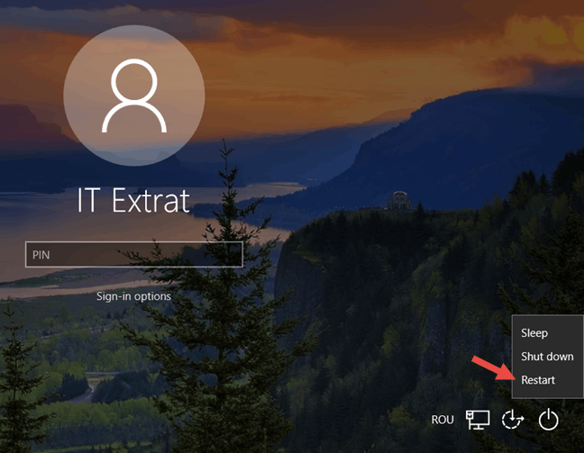

Desktops Not Included

Today, client-side attacks are more common

- Means that the attack occurs at the desktop

Yet cost of desktop logs is considered too high

- If the strategy is to collect everything, it is true
- If the strategy is to stay nimble and tactical, it is more expensive not to log…

If desktops are the main point of attack … you might need them

Unfortunately, most organizations do not collect workstation and laptop logs due to the cost of collection. Yet workstations and laptops are often the target or entry point of most attacks. If the goal is early detection, then how is it possible to win if logs from these systems are not being collected and analyzed? The truth is, collecting everything on workstations is not cost effective. Yet the tactical collection of specific logs is low-cost and is likely to save an organization money due to the benefits of early detection they provide. Usually, organizations respond that they can monitor these systems using logs from endpoint protection suites. Unfortunately, many of these systems are focused on known bad actors and will perform poorly and providing early detection. Application control products and incident response tools can provide a wealth of data but often requires many man hours to configure properly before high-fidelity detection exists. Regardless of third-party products, the point is that Windows, by default, creates some extremely high-value logs that can be used for catching malicious activity. Another example is malware sandbox systems. These are used to launch executables and monitor for bad behavior intentionally. Yet this author has experienced a lot of malicious malware that was not caught by the sandbox but would be from basic Windows event monitoring.

Desktop Logs vs. Server Logs

Fear of collecting desktop logs is due to costs

- If the cost of logs from a server is X, then the cost of 10,000 desktops must be X times 10,000
- Yet desktops log significantly less than servers

Desktops generate fewer logs and filtering can be specific
- Only specific events need to be collected
- Key is to focus on tactical data only

Volume of logs can be kept extremely low

While partnering with one organization, this author almost got thrown out the door for recommending desktop logging. The reason from the organization is they believed it was an ill-advised recommendation that should not come from a subject matter expert. In their heads, they assumed the cost of monitoring 2000 servers was going to increase by a factor of six to include monitoring desktops. Yet, when this was finally voiced, it was explained that monitoring 10,000 desktops would only increase hardware and software requirements by a small fraction (approximately 5%). Since desktops and laptops are usually initial entry points, it makes sense to, at a minimum, perform targeted event collection. Workstations are perfect candidates for only collecting special events of interest. This keeps the volume of logs collected to a minimum yet provides actionable data.

Collection Strategies: Server Only

Log All: Input-driven

Overwhelming number of logs

Targeted: Output driven

Significantly fewer logs (> 80% reduction)

This slide is a visual demonstration of the two main collection strategies in regard to Windows and Linux logs. This slide represents monitoring only servers. This author regularly sees organizations follow the left portion of the slide, which is monitoring servers only but also collecting all logs. The left portion represents following an input-driven model. In this case, organizations only collect logs that are actionable or relevant. This typically results in an 80 to 90 percent reduction in logs collected.

Collection Strategies: All Endpoints

Overwhelming amount of logs - Log all: 90% desktop, Targeted: 90% servers (significantly fewer logs > 80% reduction)

This slide is a visual demonstration of the two main collection strategies in regard to Windows and Linux logs. This slide represents monitoring both servers and desktops. When following the input-driven (collect everything) strategy, the inclusion of desktop servers is cost prohibitive. In this case, approximately 80-90 percent of logs are likely to come from desktops. In organizations that historically only collect logs from servers, this could increase costs about almost 10 times. On the other hand, following an output-driven (collect only specific events) strategy is likely only to have a minimal impact when adding workstation logs. With this strategy, workstations will often consist of 5-10 percent of the total logs.

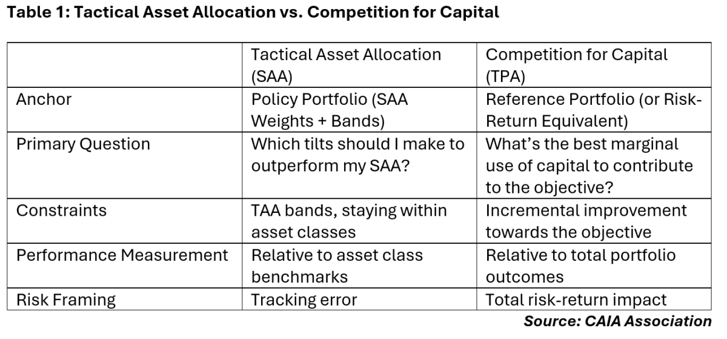

Visually, it is easy to see the difference in input-driven (all inclusive logging) vs. output-driven (tactical, or selective logging). This slide visually represents how much data would need processing and storage depending on the model of collection. For example, if you were to collect logs from desktops and servers — but only those logs you knew were useful – they, collectively, will still be much smaller than collecting all logs from servers only.

Hybrid Collection

There may be value in new or unknown logs

- No collection means no capability for future use
- Yet, collecting everything is not cost effective

Good approach is to collect everything and analyze

- Frequently occurring events that do not add value should be omitted
- This should become an ongoing process

This methodology can also aid in lowering compliance costs

Life is not black and white, and neither are logging strategies. This author prefers to follow a hybrid collection method rather than a straight input-driven or output-driven solution. This involves collecting all logs but regularly looking for the most frequent events that do not add value and eliminating them. This technique takes roughly 15 to 30 minutes of one person’s time and should be performed on a regular basis such as weekly or monthly. If you are looking for a method to lower costs, this is it. Using this technique can literally shrink the total number of logs by over 50%. Also, since the logs are initially in the system, the data can be used to quantify the cost of keeping specific events. This means that if you have a log you think you may need but are not sure you really need it, the cost of keeping it can be quantified into a business decision.

Compliance

Compliance is a costly and confusing beast

Example: PCI DSS Requirement 10

- Log all “in scope” assets
- Must have 1-year retention
- 3 months of accessible logs

Above is straightforward, what must be logged is not

- “Track and monitor all access to network resources and cardholder data” <- Does not mean everything

Compliance is meant to be treated as a business requirement. Yet it is not always understood. There are many compliance frameworks that mandate logging, yet few are precise as to what must be logged. Typically, these frameworks will define the logs that must be retained and what the retention requirements are. This is where most input-driven collection comes from. The spirit of compliance is to collect logs for auditing as well as detection. Compliance does not exist to make lives miserable. However, the interpretation of many compliance frameworks has given compliance a bad name. This does not mean that there are no compliance requirements that may be excessive. They do not exist, but they are not as common as people think. An example of this is PCI DSS. It clearly defines log retention for in scope assets. To some extent, especially in newer versions, it clearly defines things that need logging. However, there are still multiple areas of confusion where it is unclear if something must be retained. If you find yourself in this position, do not fall into the “I must collect and retain all logs” category. Instead, try discovering the most frequent events you feel are unnecessary, then ask. For example, PCI DSS requires a QSA or ISA to sign off on your PCI compliance. If you provide them a list of event logs you do not think are necessary and the reasons why, they most likely will agree with you or at least approve most of the exceptions. 

Finding Noise



Regularly looking for noise and eliminating it:

- Increases performance
- Increases analysis speed
- Decreases costs
- Is easy to do…

Regularly looking for logs that are noise and eliminating them is an easy, quick win. This simple process will increase the performance of searches within the SIEM. After all, less data means lower hardware utilization. This alone will improve an analyst’s speed, but so will the fact that there are fewer logs to filter through. Eliminating noise is something that should be done regardless of collection strategy. It is easy to do and can save lots of money while providing many other benefits. This slide shows a simple graph based on Windows logs.

Eliminating Noise

Elimination of noisy events can be filtered in various ways.

- At the log aggregation point
  - Overhead exists at the central point
  - Easy to maintain and update
- At the endpoint
  - Scales well by decentralizing filter overhead
  - Requires strong asset management and change control
- At both the endpoints and log aggregators

The process of eliminating noisy events can be controlled at either the endpoints or the log aggregation point. Filtering at the log aggregation point tends to be the most common and recommended by vendors. However, it often involves endpoints still sending noisy logs over the network – only to be dropped. This is inefficient. Additionally, it may still count against software licensing. The clear advantage of filtering at the aggregation point is centralized management.

Filtering at the endpoints decentralizes the filtering process, so it tends to scale better. However, for this to work, there must be a way to centrally control endpoints so that they regularly get updated with any new filters. The disadvantage is that organizations require strong centralized management to decentralize the process. The advantage is that less network bandwidth is consumed, and it can lower costs by reducing hardware requirements and software licensing. As previously stated, vendors often state that filtering at the endpoint is against best practice and can cause performance problems on the endpoints. This may be true if performing complex regex operations to decide what to drop; however, this often is not the case. This is especially not true on Windows. Again, the logs follow an XML schema and are stored in channels, meaning the Event IDs and channels are easily referenced for filtering. If you are encrypting logs, it is more likely the overhead of encrypting the logs is greater than the overhead of filtering. This makes the assumption that the log agent you are using treats the log as XML or JSON rather than syslog.

Advanced Noise Filtering

Filtering does not need to be high-level

- Some events generate tons of traffic, but only a fraction of the logs actually matter.

Example: Collecting new service creation events

- You probably only care about new or deny listed services
- Means that 99% of logs are likely not to matter
- Machine A installs Chrome… Google Update Service #1
- Machine B installs Chrome… Google Update Service #2

If an event is generating lots of noise, you typically have three options. Live with it, filter it out completely, or create a more complicated filter to eliminate the noise. For example, if you were collecting new service creation events and only cared about never-seen-before services or deny list services, then you would need to create a more complex filter. By default, collecting Windows event ID 7045 (A service was installed in the system) will be almost entirely services that do not match your use case. If Google Chrome is an authorized application, then its corresponding Google Update Service likely is, too. Yet every machine that installs Chrome is going to log a service creation event for the Google Update Service. To address this issue, a log agent or a log aggregator can be configured to collect event ID 7045 but drop the event if it matches a list of authorized service names. Some SIEMs automatically build and maintain this list on your behalf. For instance, if you are using the open-source Elasticsearch stack, you can utilize ElastAlert to monitor for new service name values automatically and alert only on new services…

SEC555 Workbook Exercise 3.1: Windows Log Filtering

Exercise 3.1: Windows Log Filtering

- Exercise 3.1 is in the digital wiki found in your student VM (recommended)
- Alternatively, you may use your Workbook

Collecting Logs

Recommend using log agent over agentless

- Either built-in agent (event forwarding or syslog)
- Or third-party agent (commercial SIEM agent, NXLog, Beats, etc.)

Things to consider:
- Filtering capabilities
- Functionality and flexibility
- Management overhead

Once a collection strategy and the systems targeted for log collection have been decided, it is time to actually implement collection. While agentless log collection is available, a log agent is recommended. This holds true even if it is the built-in Windows Event Forwarding agent (or whatever Syslog agent Linux is using). Let’s be clear, these are log agents.

Some organizations state that they do not support the installation of a log agent on systems. The truth is that Windows and Linux both have log agents already on them. The only difference is, in Linux the syslog agent is already installed and running but is not sending logs over the network. On Windows, the log agent is installed but is not running. This is why if you follow the guide for setting up Windows Event forwarding, the service Windows Event Collector has to be turned on. That service is the log agent being referenced. Technically, if you enable this service, you are changing the functionality of the system as the native Windows agent functionality is not enabled until this service is started. To achieve the most flexibility and functionality, a third-party agent should be considered. If you have a commercial SIEM product, assess the PROs and CONs of the product’s native log agent. However, do not blindly accept that it is the best agent for your organization. Compare it to a few alternatives, as it may save time and money while providing more functionality and flexibility.

Windows Event Forwarding

To collect logs using Windows event forwarding is a two-step process

- An event collector must be set up
- Then, either the collector must be configured to pull events or endpoints must be configured to push events

GPO is used to tell endpoints what logs to push
- Configuration of event selection is similar to push/pull

The end destination is intended to be Windows, not SIEM

Windows Event Forwarding

The native Windows log agent is the Windows Event Collector service. It is used to set up Windows Event forwarding to a centralized system. The centralized collector system can be set up to either reach out and pull logs or listen to and receive them. This built-in centralized log collection technique is not as publicized as it should be. It is free, assuming you have valid Windows licenses, and is easy to set up.

If you have no SIEM, this may be a good starting point. This could be set up in the span of a few hours and is simple to understand. Windows event forwarding does not support forwarding of ETL files.

